Specific facilities provided for women

Girls Common Room: To facilitate students, the College established a spacious and comfortable common room where the girl students may sit, rest and go for recreation.

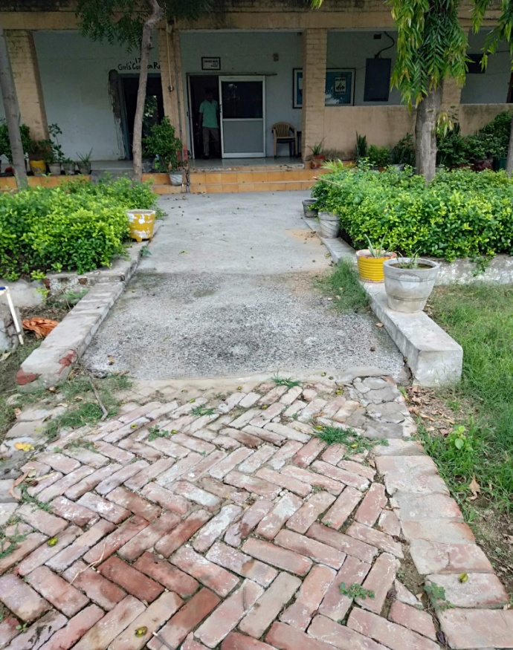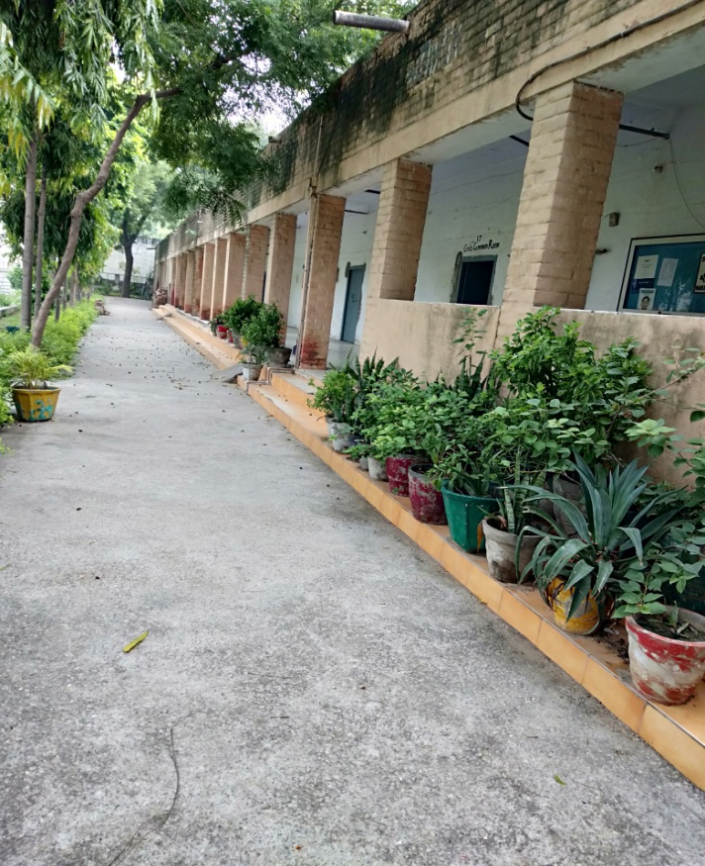

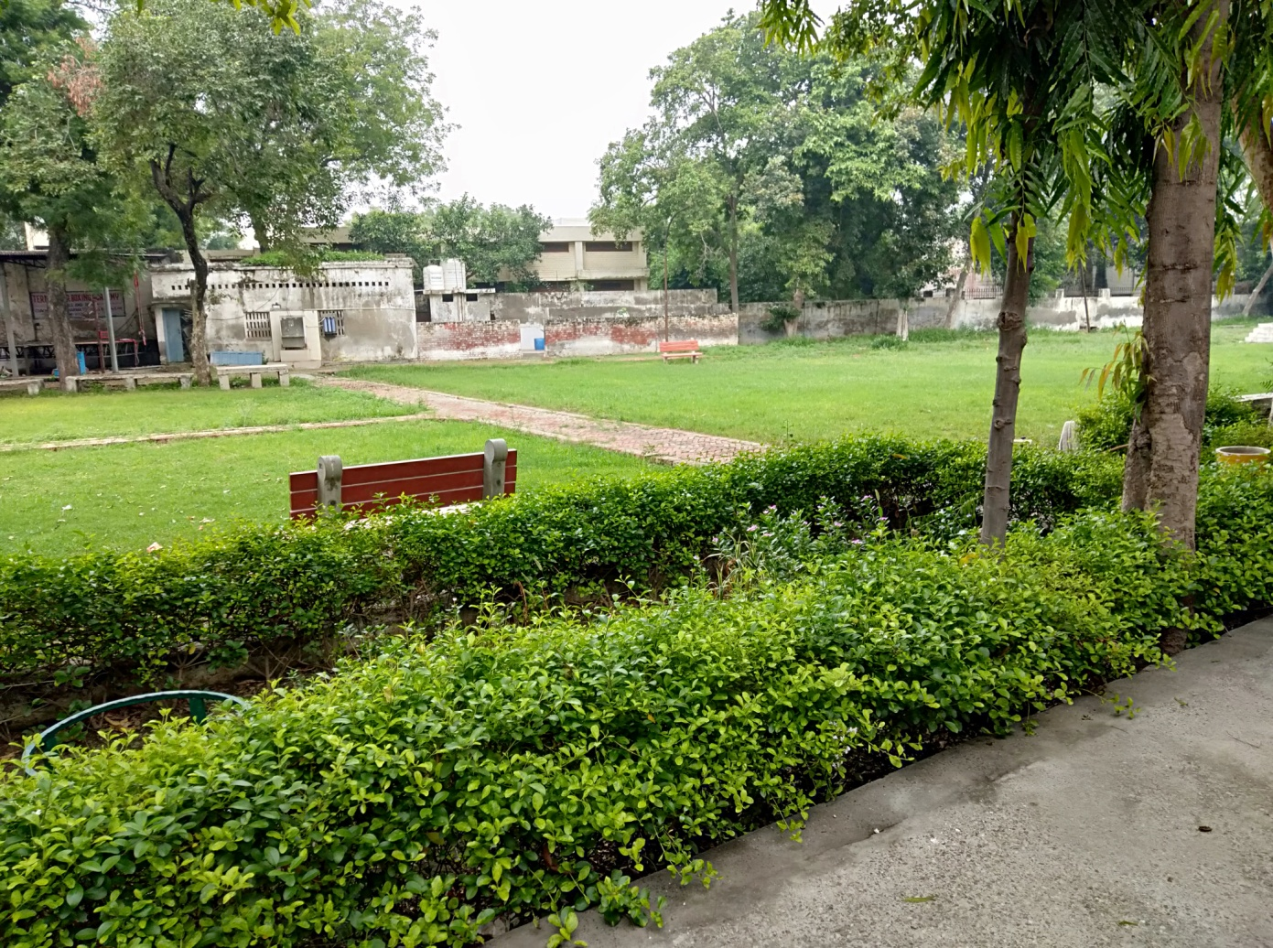Lawn

Women Cell: - To ensure the security, safety, welfare, inculcating skills, empowerment and counselling of female students, the Department of Higher Education, Haryana provides provisions to constitute a Women Cell in the Colleges & also provides the financial assistance under budgetary provisions for the said purpose. Women cell organises and conducts various activities and intercollege functions, workshops for the empowerment of the girl students. A female attendant is also available to facilitate the students under the in-charge of Women Cell.

Gender Equity (Number of gender equity promotion programmes organized by the institution during the year 2020-21)

Title of the programme | Period |  | Participants
 | from | to | Female | Male
International E-workshop in collaboration with women cell of KanyaMahavidyalya, Kharkodha on the topic “Women Leadership Matters” | 13-10-2020 | 13-10-2020 | 100
Seven Days Workshop on “Self-Defense Training” | 18-01-2021 | 27-01-2021 | 100
Essay Writing Competition on the topic “ShikshitNaariSashakatSamaj” | 01-02-2021 | 01-02-2021 | 25
Slogan Writing Competition on the topic “ShikshitNaariSashakatSamaj” | 01-02-2021 | 01-02-2021 | 25
Poster Making Competition on the topic “ShikshitNaariSashakatSamaj” | 01-02-2021 | 01-02-2021 | 25
Extension Lecture on topic “Role of Women Edication in Women Empowerment” | 05-02-2021 | 05-02-2021 | 50
Poster making and Slogan writing competition on “Beti- Bachao, Beti Padhao” | 16-02-2021 | 16-02-2021 | 50

International E-workshop in collaboration with women cell of KanyaMahavidyalya, Kharkodha on the topic “Women Leadership Matters”
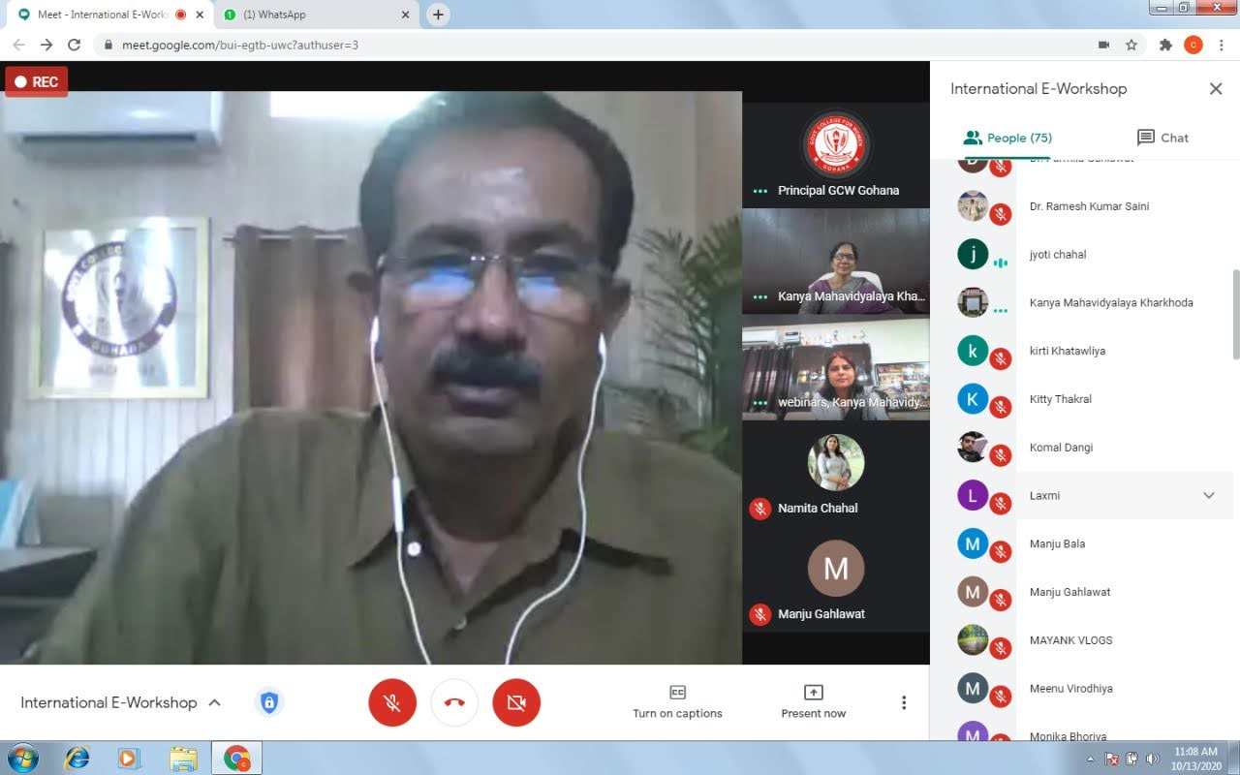

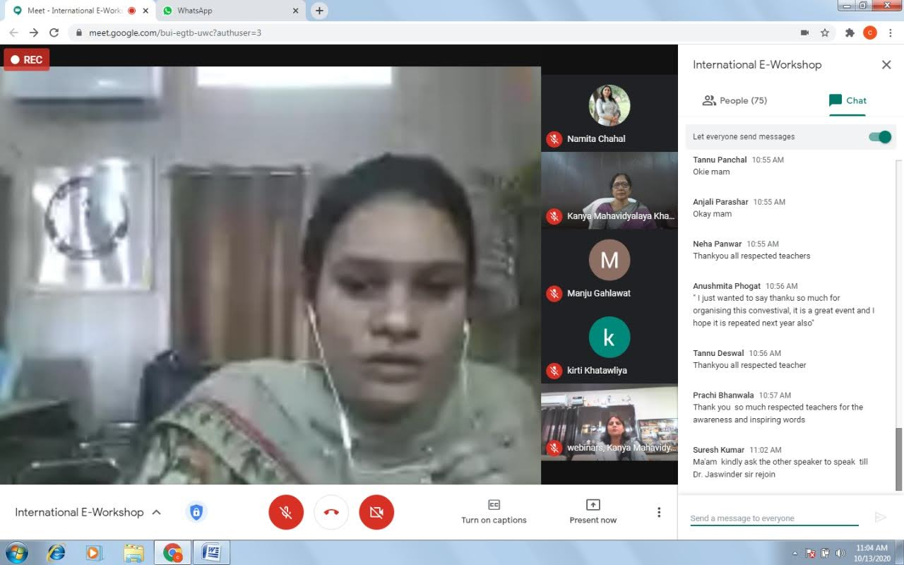

Essay Writing Competition , Slogan Writing and Poster Making Competitions on the topic “ShikshitNaariSashakatSamaj” (01-02-2021)
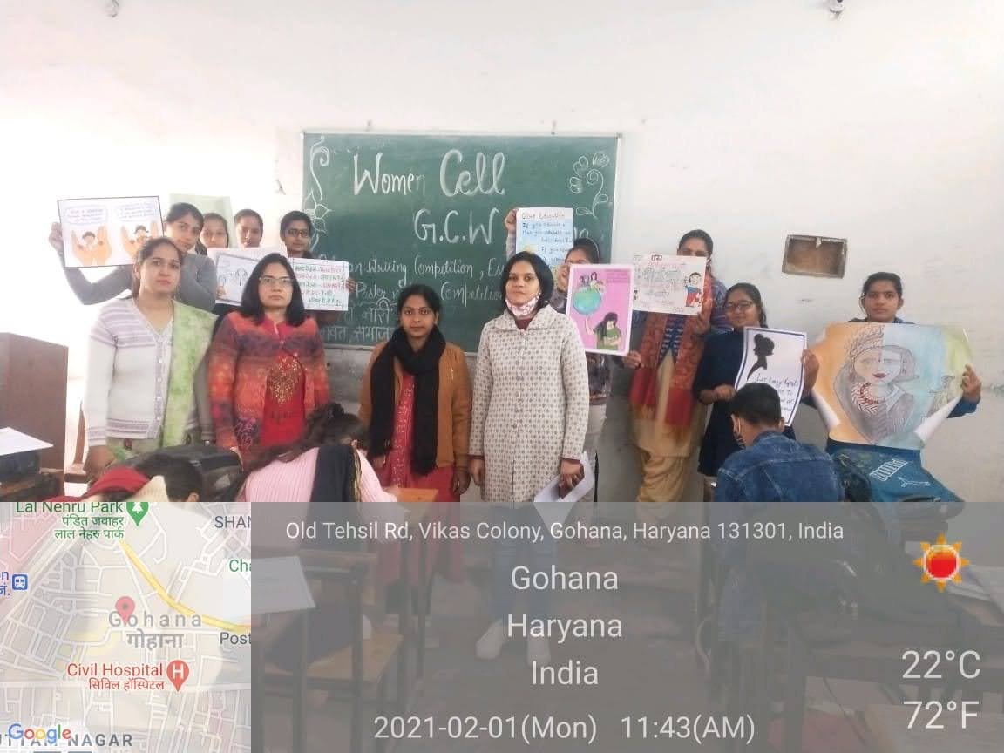

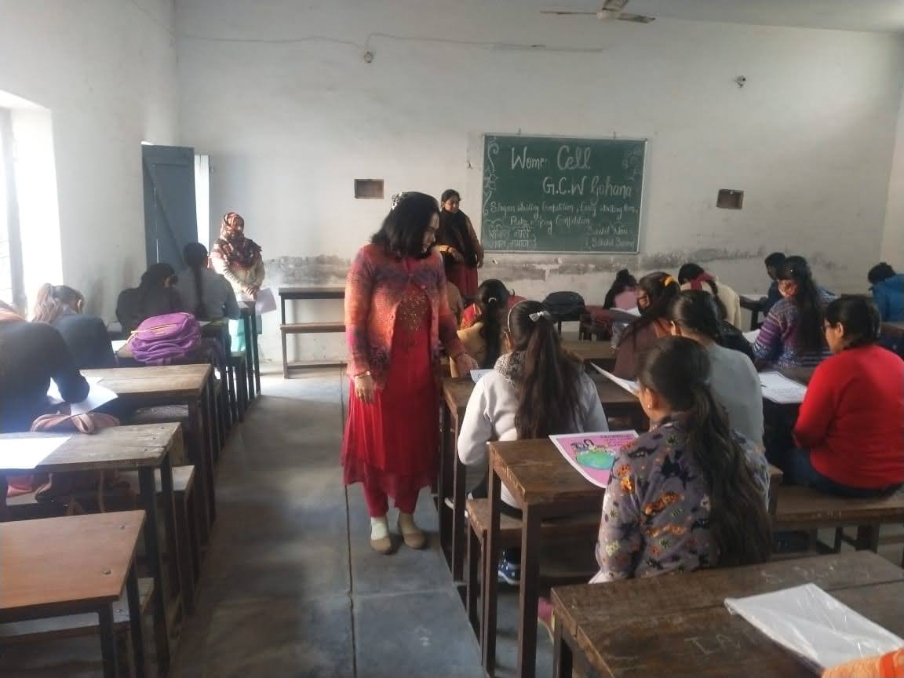
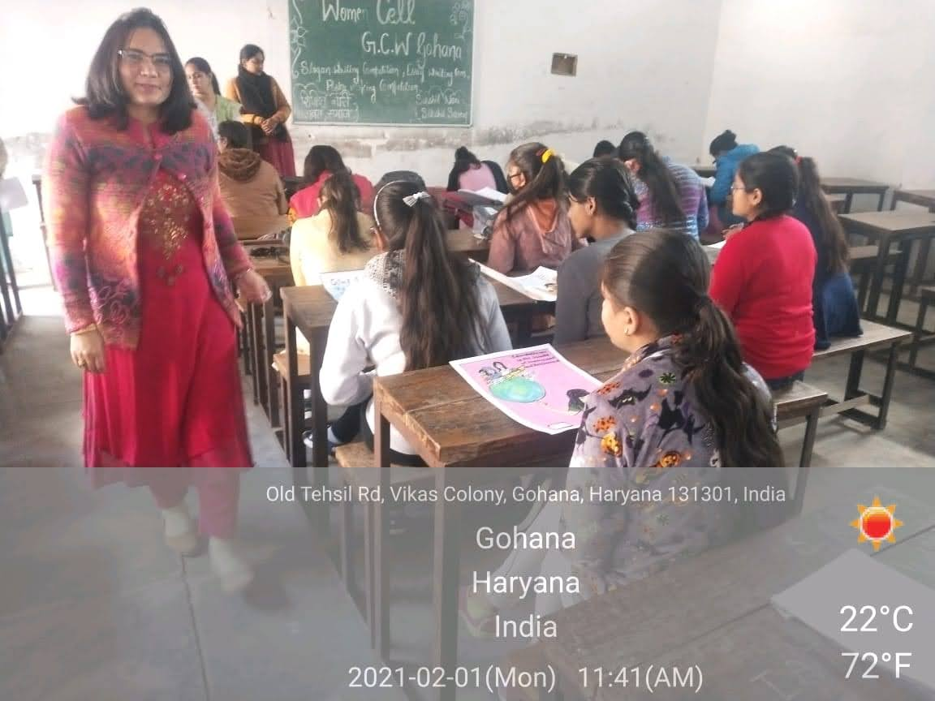

Seven Days Workshop on “Self-Defence Training” (18-01-2021- 27-01-2021)

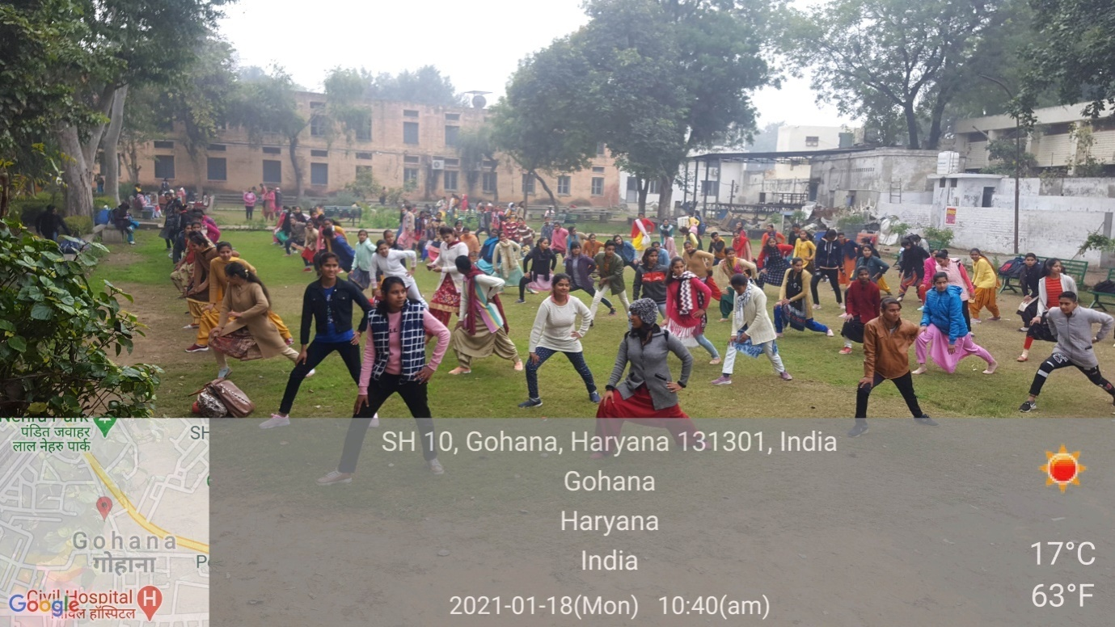
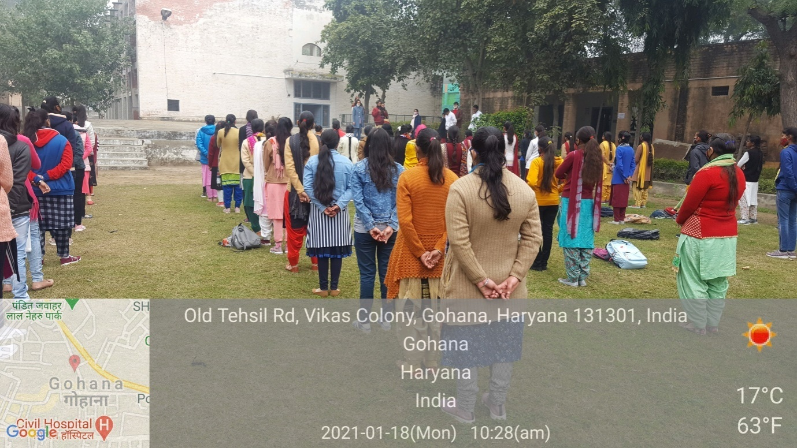
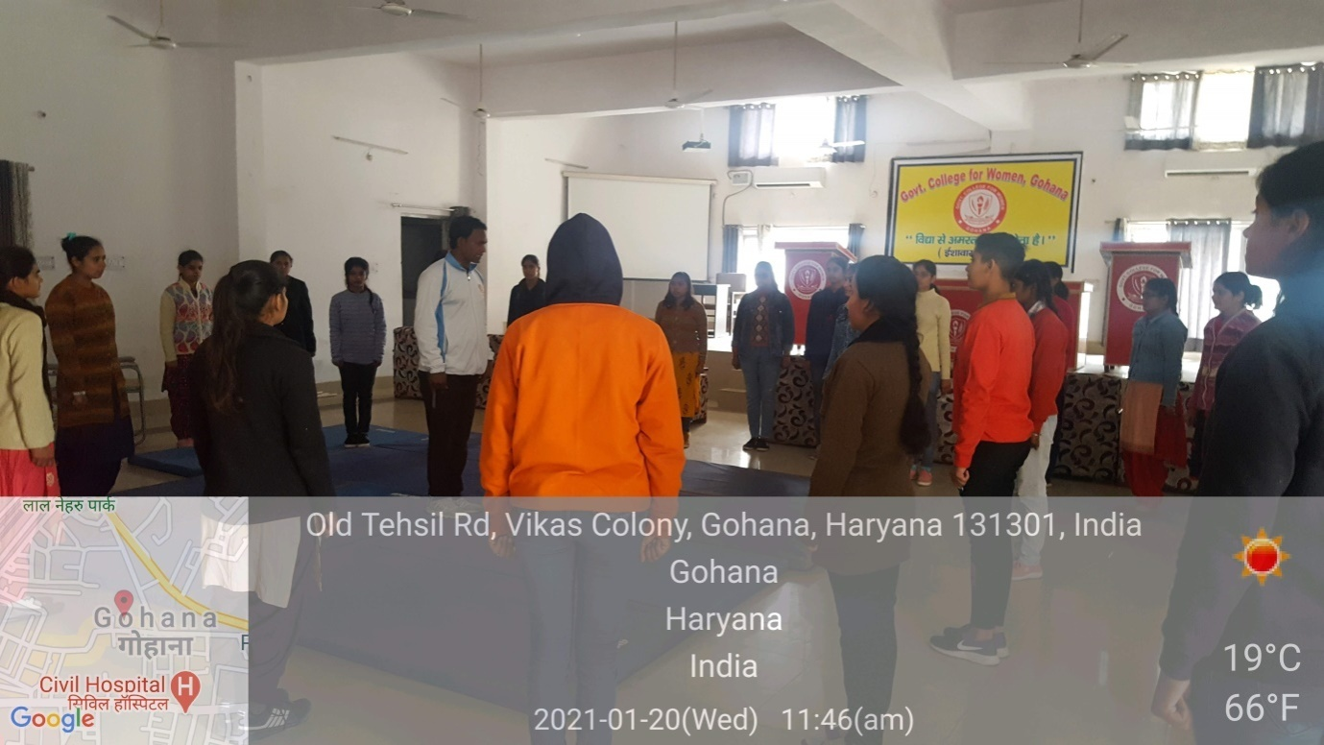
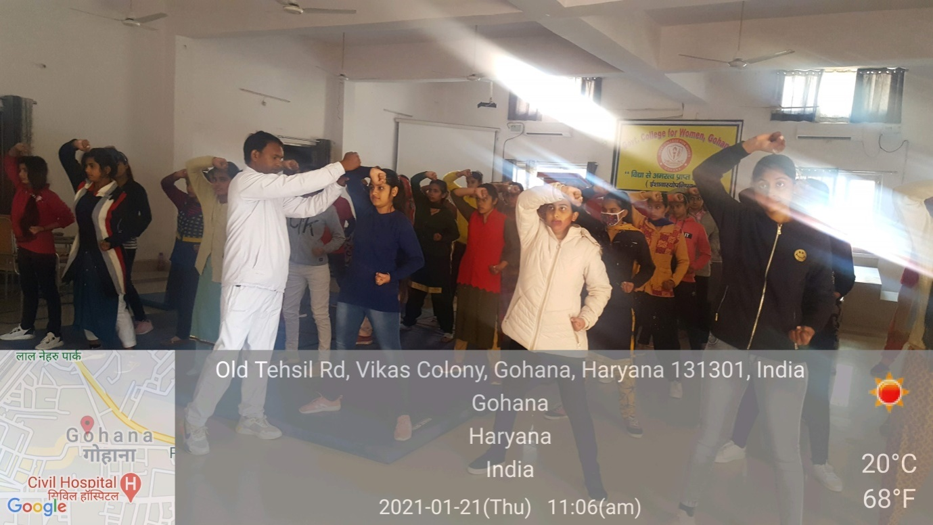
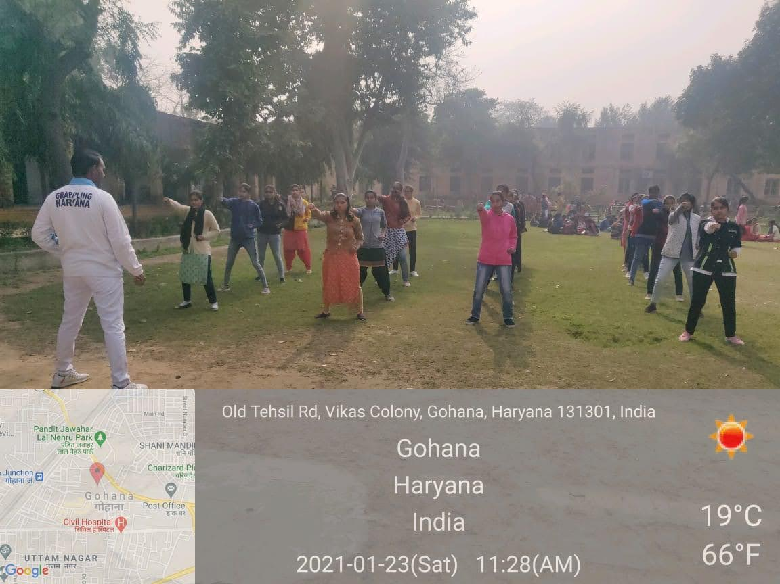
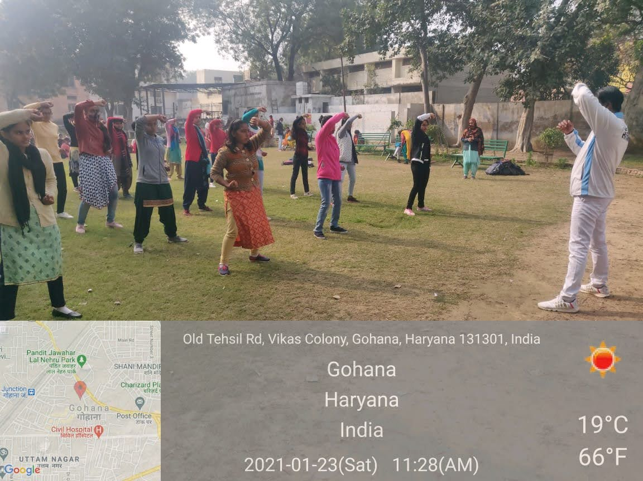
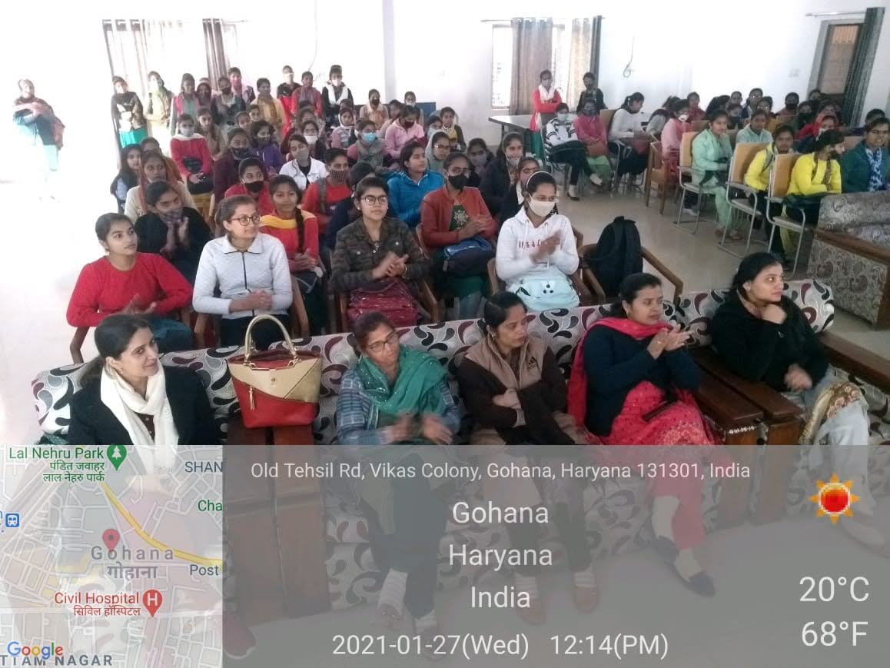

Extension Lecture on “Role of Education in Women Empowerment”

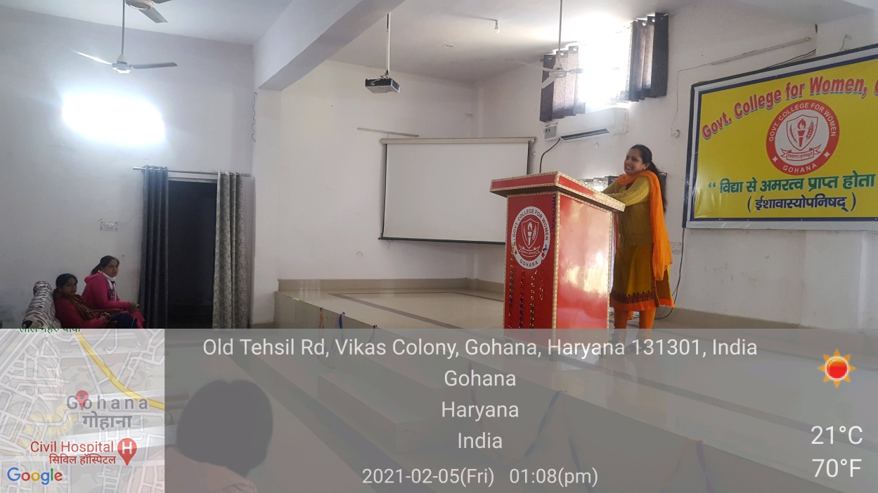
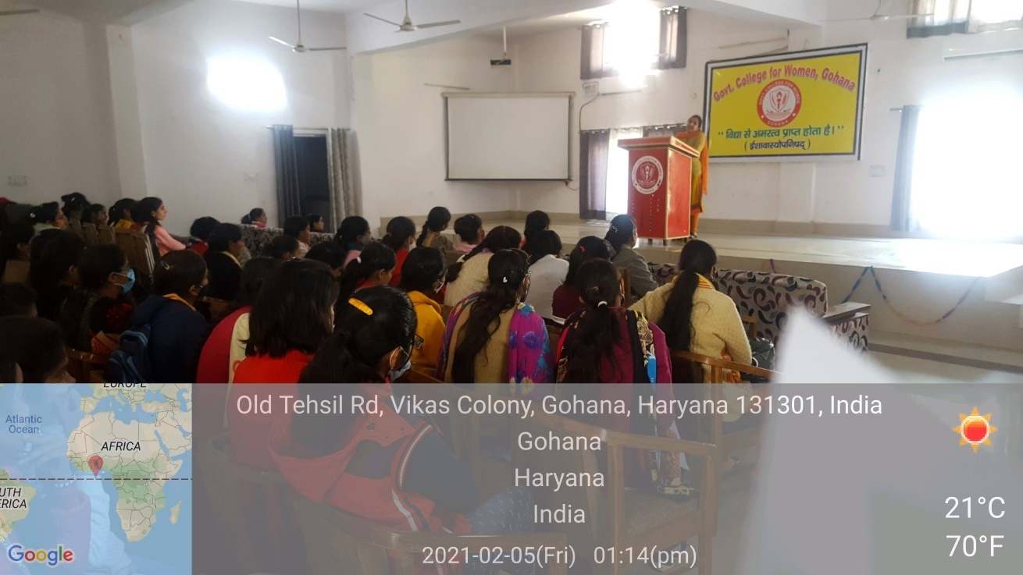

Principal

