Institutional Distinctiveness
Title: Women empowerment
Objective:
The majority of our college's students are from rural areas close by. The goal of the institution was to encourage female education and enable them to become responsible citizens. Women's cell has been developed to empower female students and assist them in all aspects of their lives in order to ensure their holistic development. Women's cell, as well as other cells such as NSS, NCC, YRC, and Legal Literacy Cell provide a forum for girls to share their experiences and opinions on their rights and responsibilities, as well as suggest methods to improve and empower themselves. Various cells support women's empowerment through hosting extracurricular events, extended lectures, and seminars, such as "Women Leadership Matters" was the topic of an international workshop. An extension lecture on the "Role of Women Education in Women Empowerment" was held by the women's cells. Also, an Extension lecture , Declamation competition and Essay writing competitions were organized on the topic “Stress management”. Seven day Workshop on “Self-Defense Training” was also organised by the women cell. Environment protection, blood donation camps, Republic and Independence Day celebrations, Yoga camp on Yoga Day, Swachhata Abhiyan, motivational lectures on various fields, rally on safety and empowerment of women by NSS and Women Cell, and so on are some of the community activities that the College participates in. NSS Day, Gandhi Jayanti, World AIDS Day, International Peace Day, Anti-drugs Day, National Youth Day, International Youth Day, Science Day, and the Anti-Tobacco Campaign are among the major events. Volunteers in Barota village also performed a play to raise awareness about the disease covid-19. A rally on "Beti- Bachao Beti-Padhao" was organised by volunteers who marched through the rural streets in a procession to raise awareness about girls' education. They are also given the opportunity to obtain a free passport through the Passport Assistance Program.
Evidence of Success:
After completing various programmes and activities, it has been noticed that the majority of students participate in numerous competitions outside of the institution and hold diverse positions. During the year, 350 students took advantage of the free passport programme.
Problems encountered: Because the majority of females come from rural backgrounds, their parents' mindset has a role in their overall development. Due to transportation issues such as late bus timings or a lack of public transportation, rural region girls commuting from villages are unable to participate in such activities.

International E-workshop in collaboration with women cell of Kanya Mahavidyalya, Kharkodha on the topic “Women Leadership Matters”
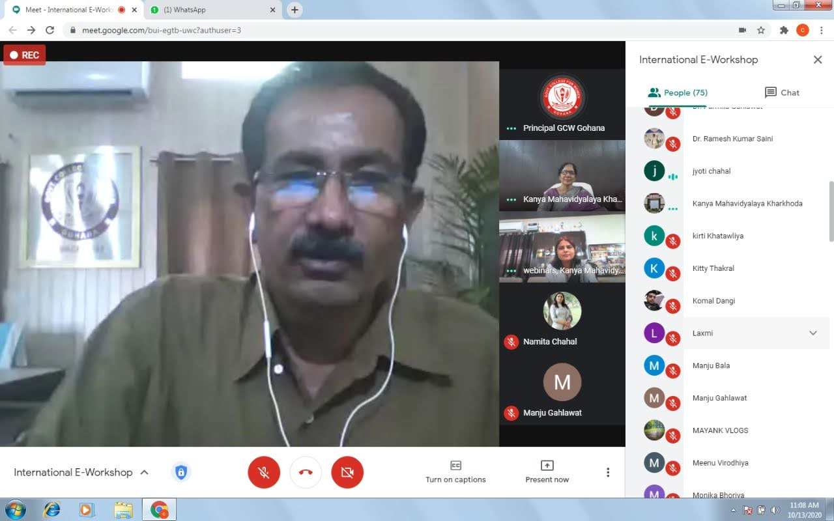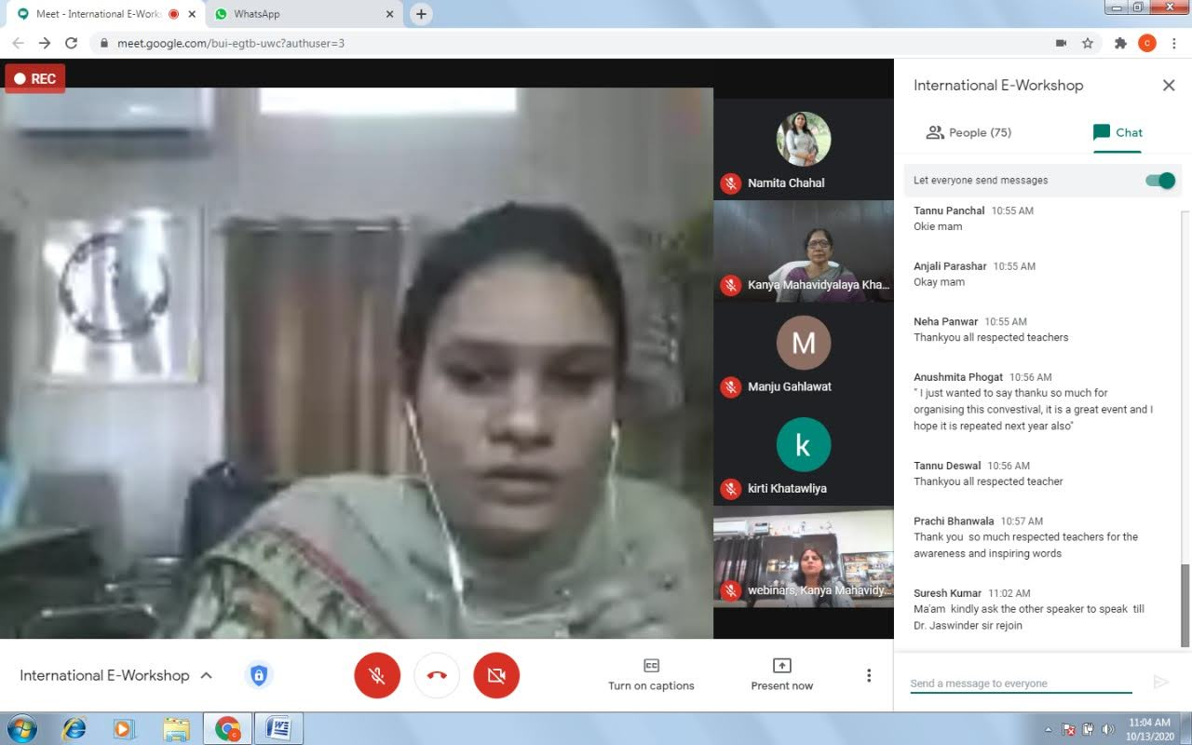

One Day Workshop on Art and Craft (15-12-2020)

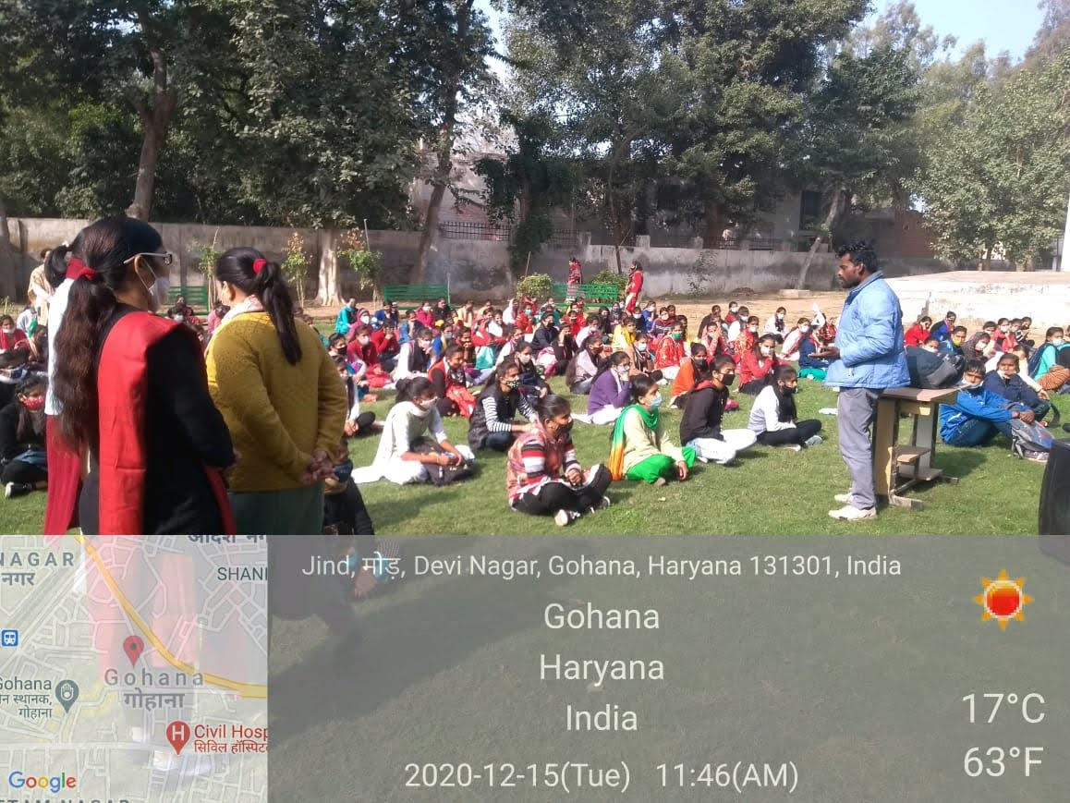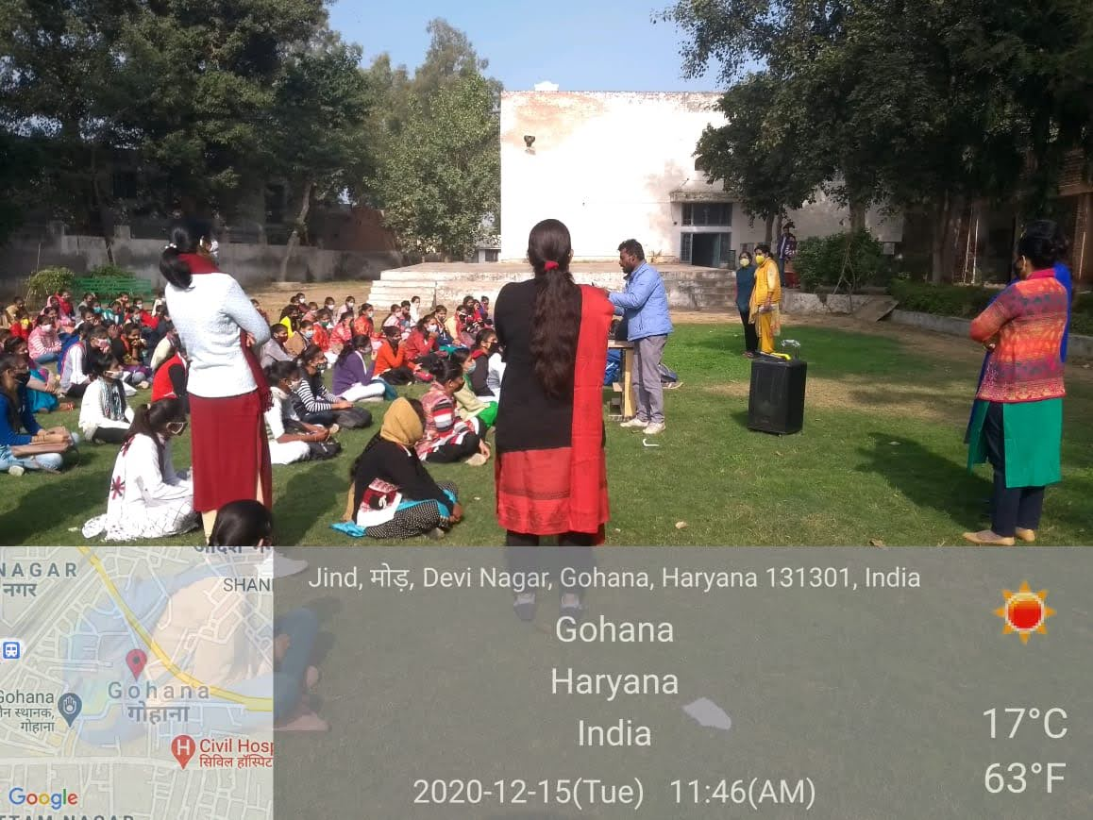

Essay Writing Competition , Slogan Writing and Poster Making Competitions on the topic “Shikshit Naari Sashakat Samaj” (01-02-2021)
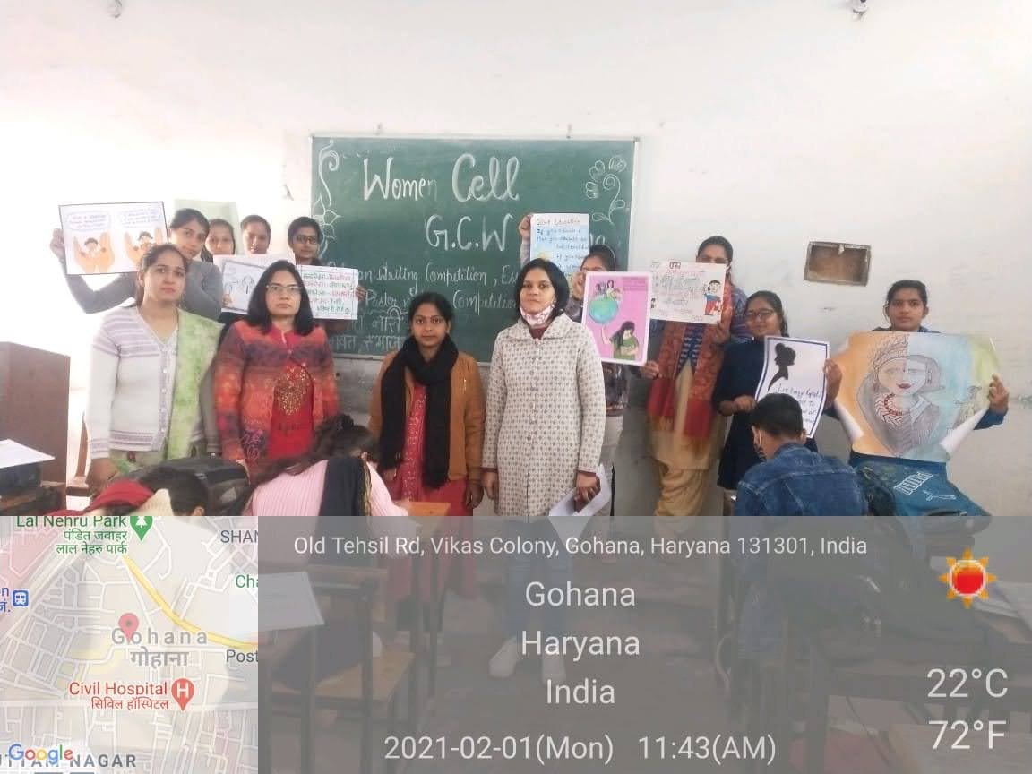

Extension Lecture on Stress Management and Essay writing and Declamation Competition on Stress Management (09-02-2021)

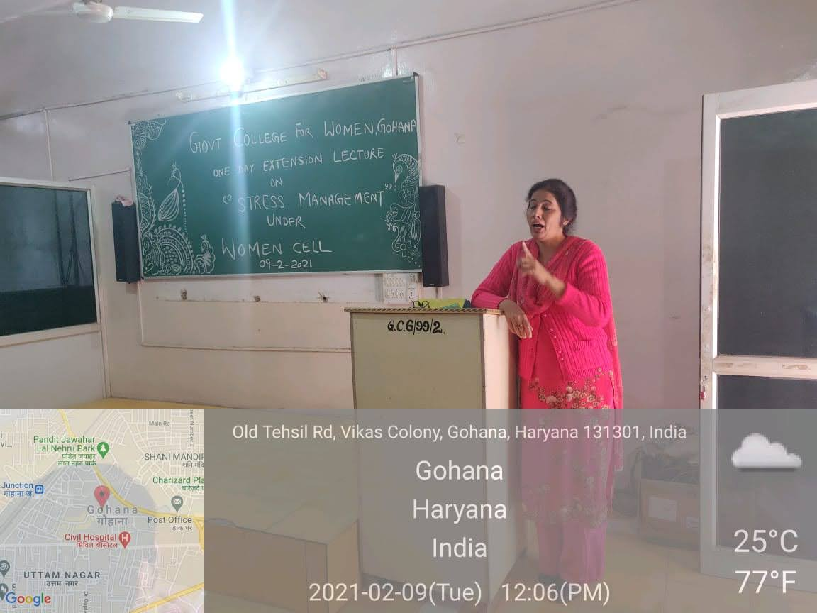
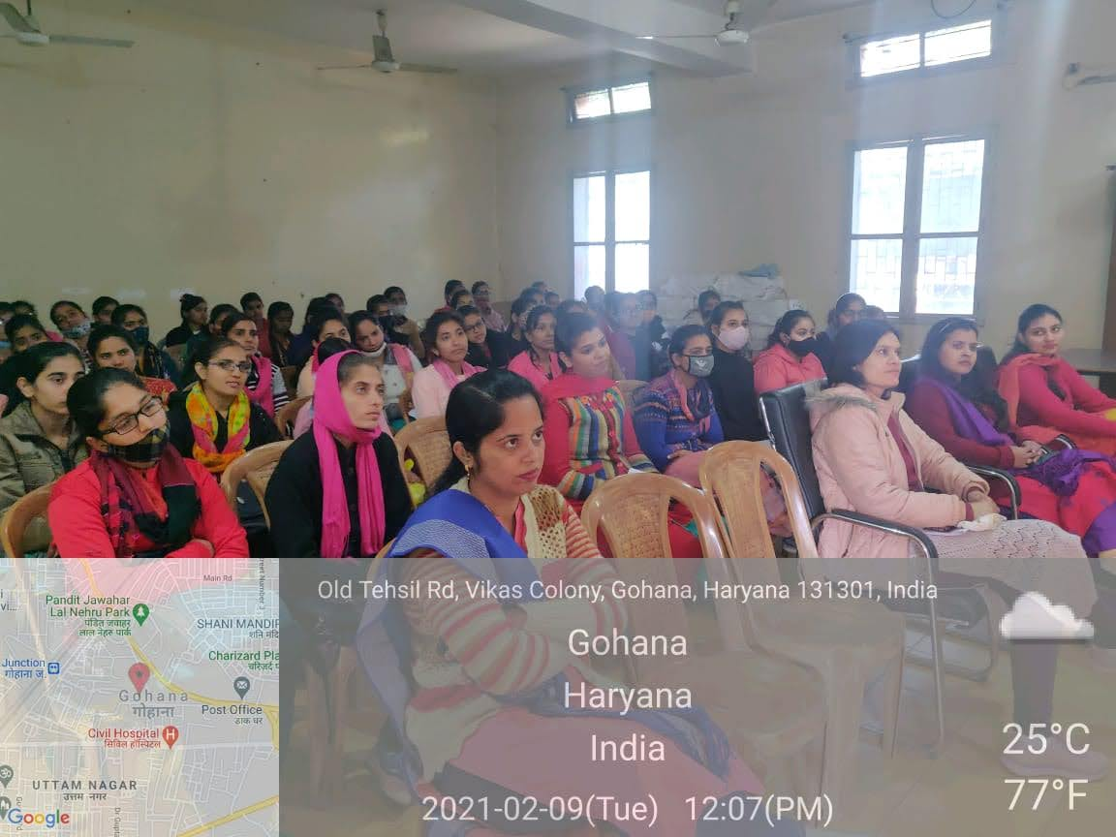

Seven Days Workshop on “Self-Defence Training” (18-01-2021- 27-01-2021)

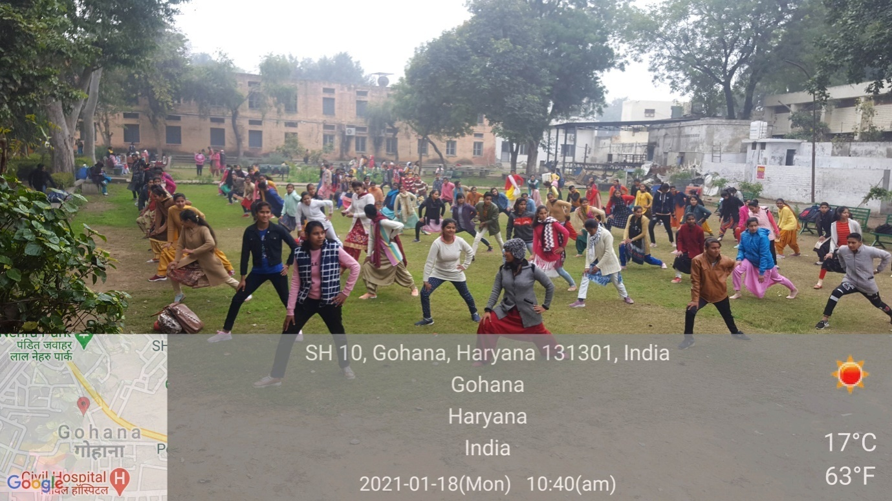
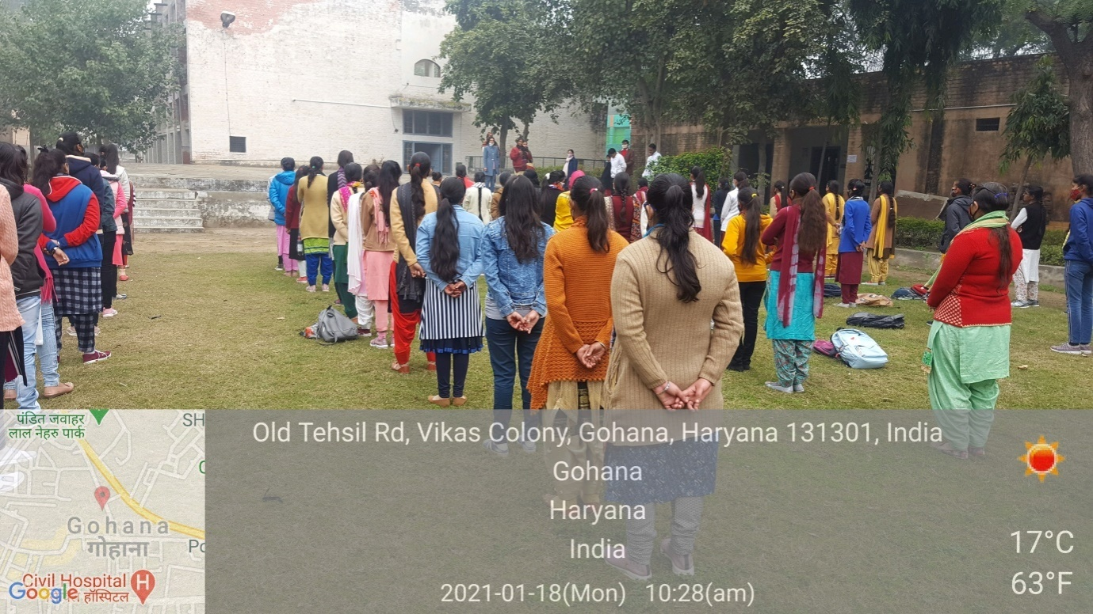
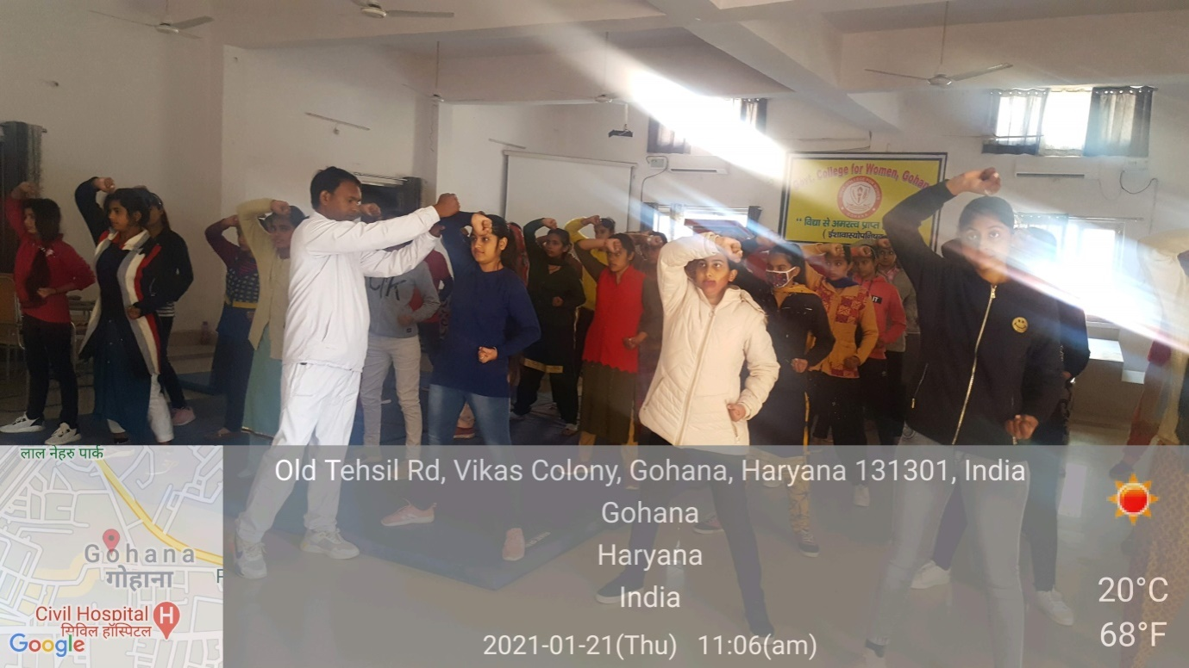
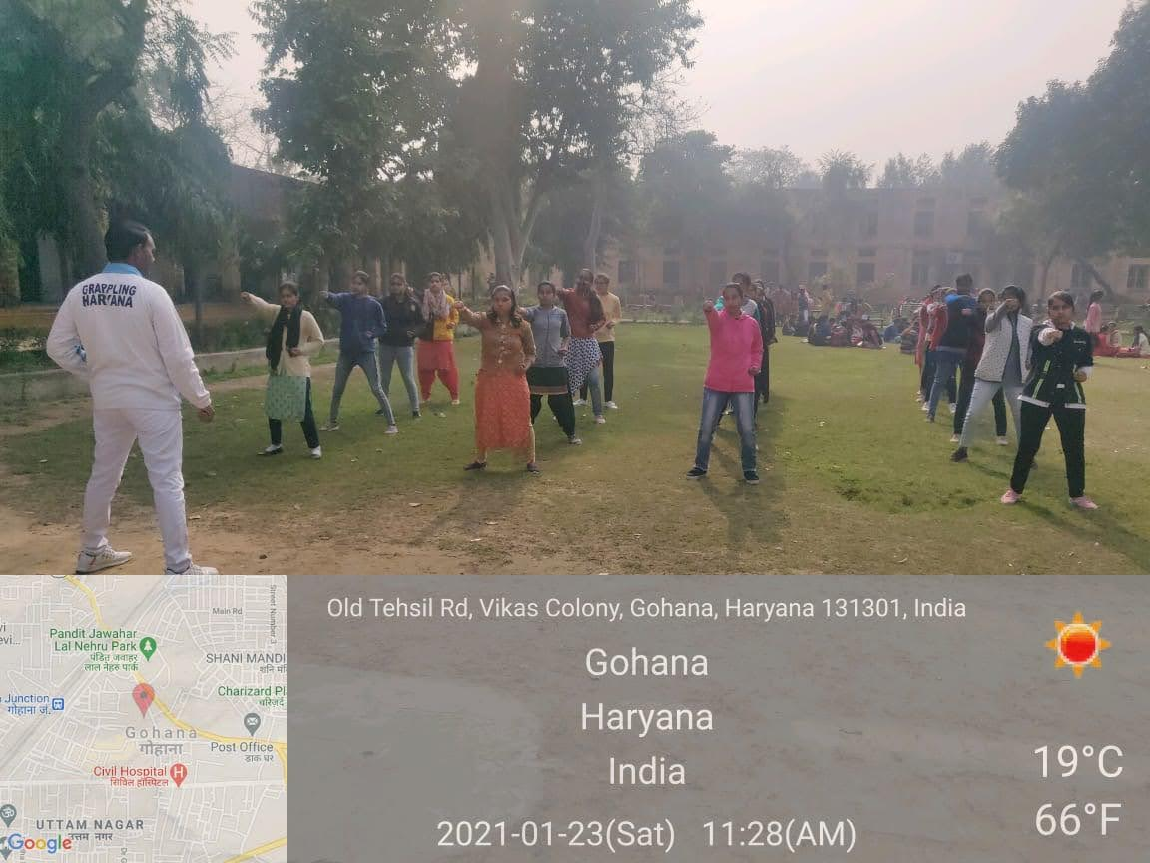
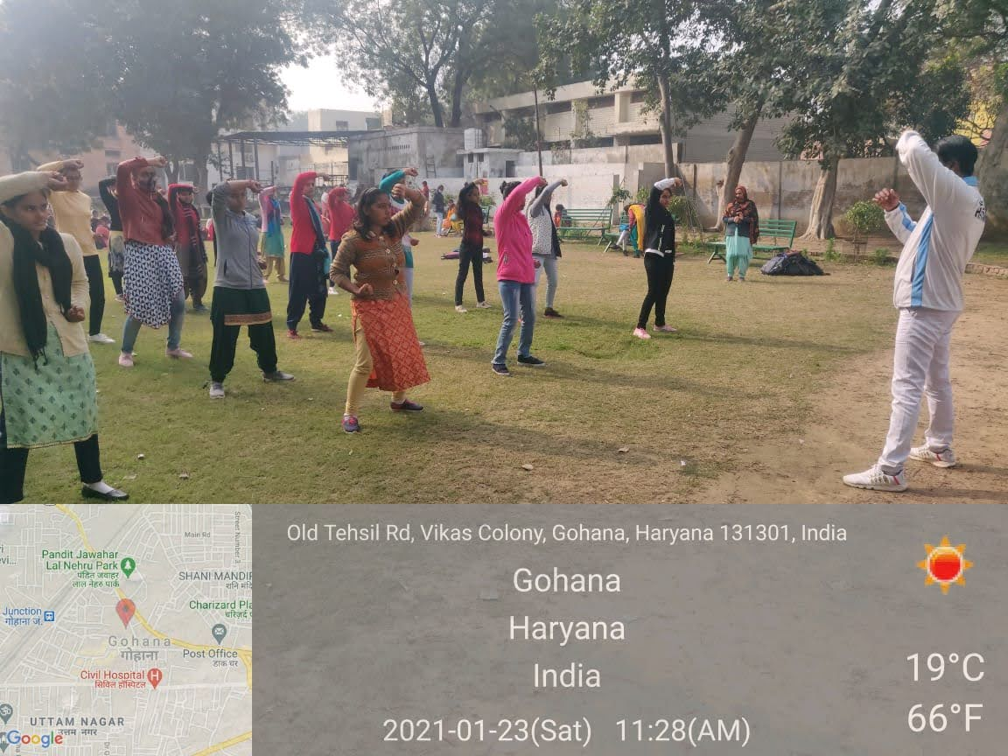
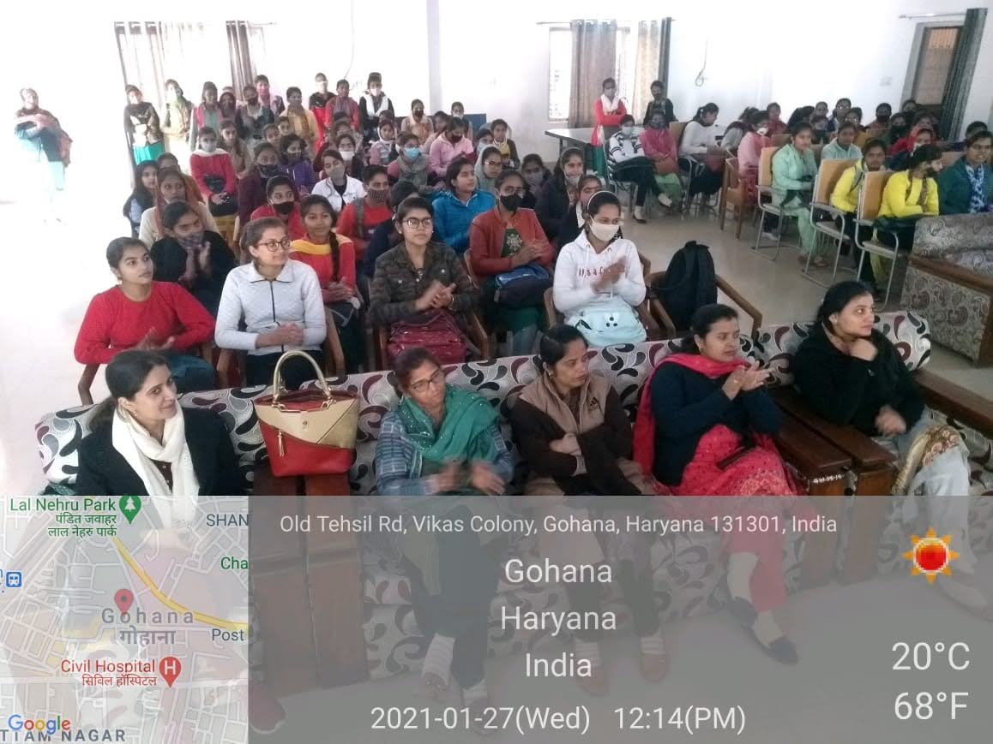

Extension Lecture on “Role of Education in Women Empowerment”
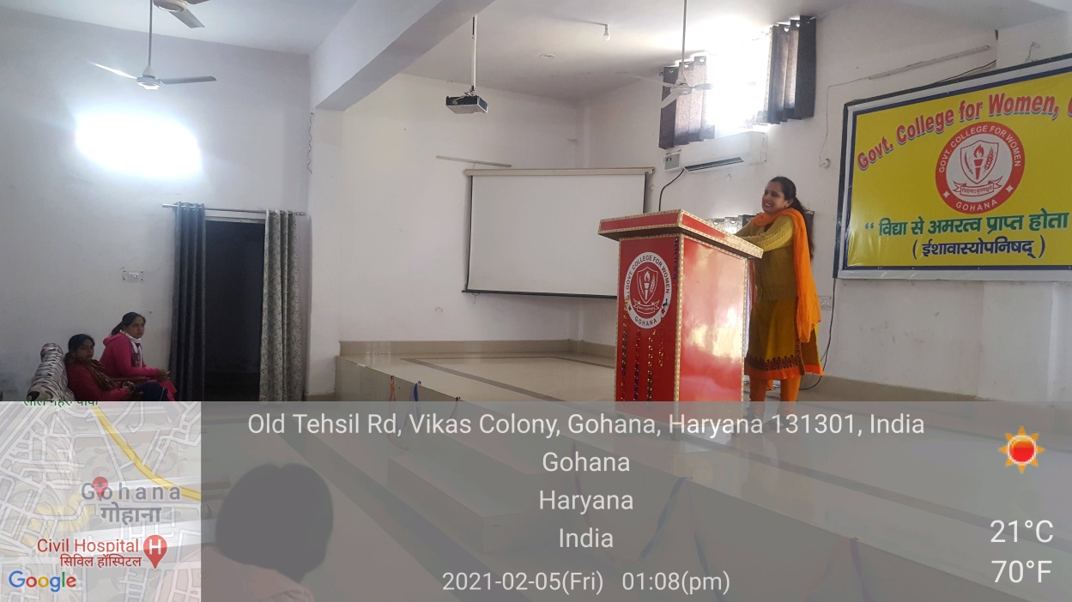
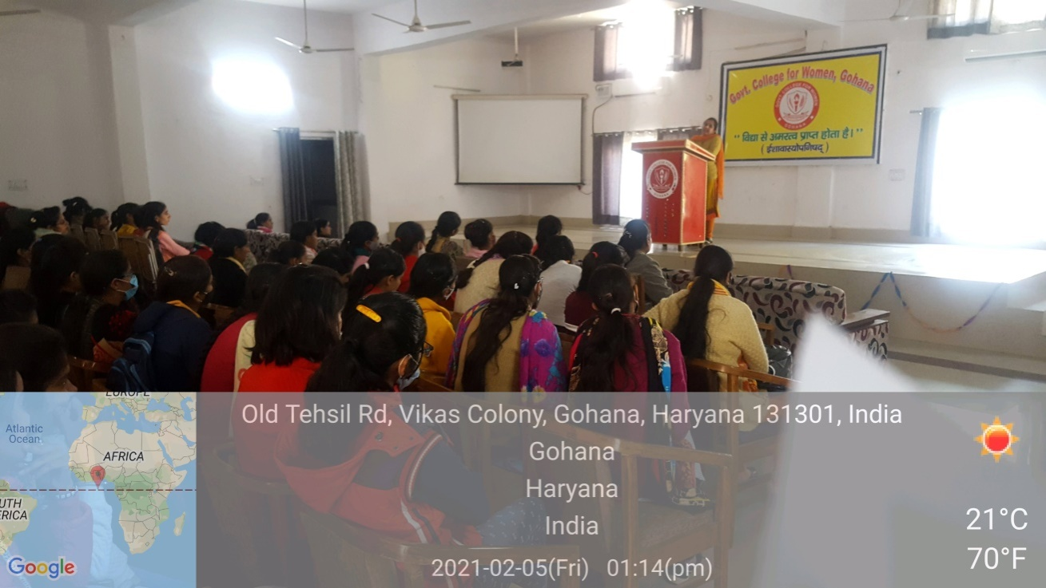

NSS
Seven Day Special Camp Report
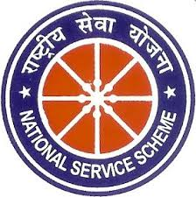

On
Fight against covid 19
By
Government College for Women, Gohana.
(Unit – II)
From15.02.2021 to 21.02.2021
At
Barota Village

Submitted to:
Program Coordinator
B.P.S.M.V
Submitted by:
MS NeerajDahiya, Assistant Professor
NSS Program Officer (Unit – I)
Government College for Women, Gohana

N.S.S Seven days Special Camp Report

Day 1, Monday, February 15, 2021.
Mr.Dineshkumar, Principal Government College for Women,Gohana, allowed for organization of seven days special camp at Barota village with the aim that volunteers will aware the surrounding people regarding how to fight against covid 19. 50 volunteers (of unit–II) participated in camp. MS Sangeeta sapra (principal of govt. college of Barota), inaugurated the camp by motivating the volunteers towards service scheme. She also told the importance of first aid and home nursing training by stating that it can help to save the lives of injured people if we know what to be done at right time.
MrsBimlaPunia(vice principal of GCW,Gohana) lessened the volunteers regarding cleanliness. He also motivated the volunteers to aware people of Barota regarding how to fight against covid 19. He energized the volunteers in such a way that this energy remained with volunteers during the complete camp.
With the inauguration of camp, first aid and Home nursing training (7 Days) of volunteers was started by trainer Mr. Sanjay Kumar from Red Cross Sonipat.
N.S.S. P.O. MsNeerajDahiya motivated the students towards selflessness. He also told them the agenda of 7 days camp. N.S.S. P.O. also divided the students into different committees like discipline, cultural, sports, refreshment and photography.

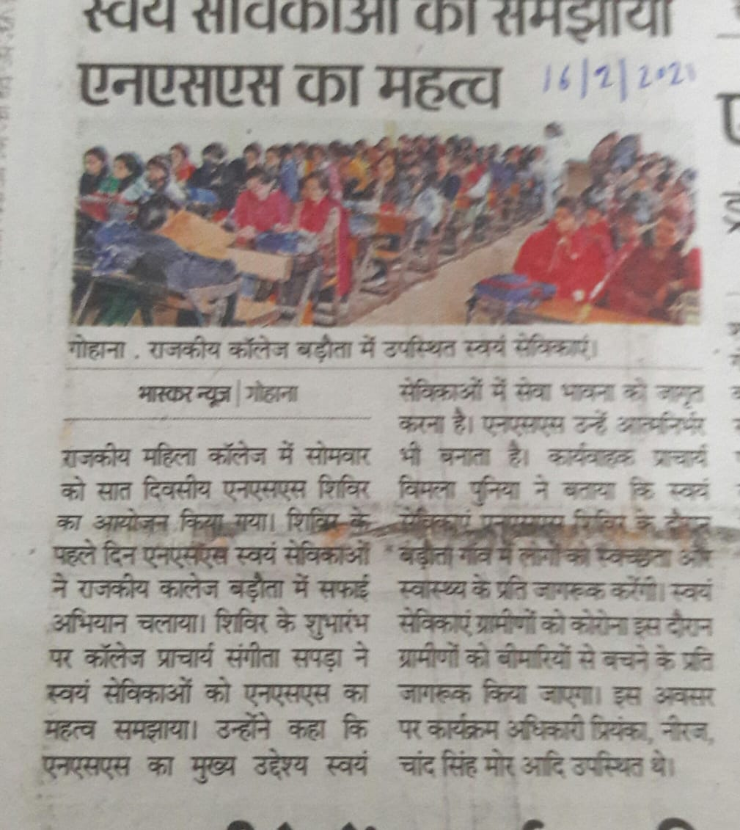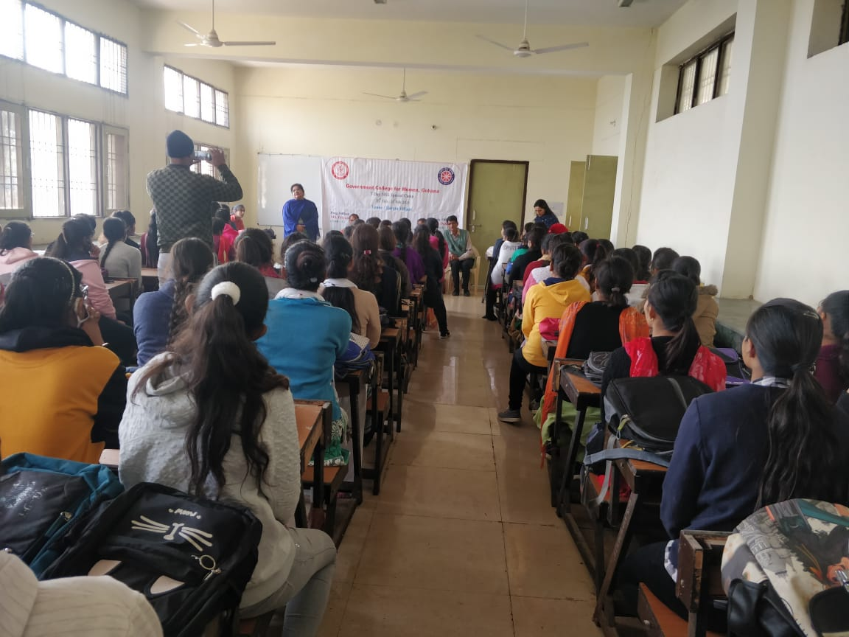

Day 2, Tuesday, February 16, 2021
Second day started with Yoga, Prayer and chanty of Gayatri Mantra.
Mr. Sanjay Kumar trained the volunteers regarding first Aid Training and Home Nursing.
In morning session Competition on poster making and slogan writing on the topic of Beti- Bachao and covid 19 was organized. All the volunteers participated in competition. Priyanka got the first position in slogan writing competition and Ankita got first position in poster making competition.
In the evening session Dr. Chand Singh mor gave a speech on environmental protection. Air, water and earth are basic amenities of life. But overpopulation and rapid industrialization have created a state of decadence in the environment. Man has constantly tempered with nature. As a result, a threat to his life has been increased due to the lack of clean air and clean water and imbalance established in the bioshhere.
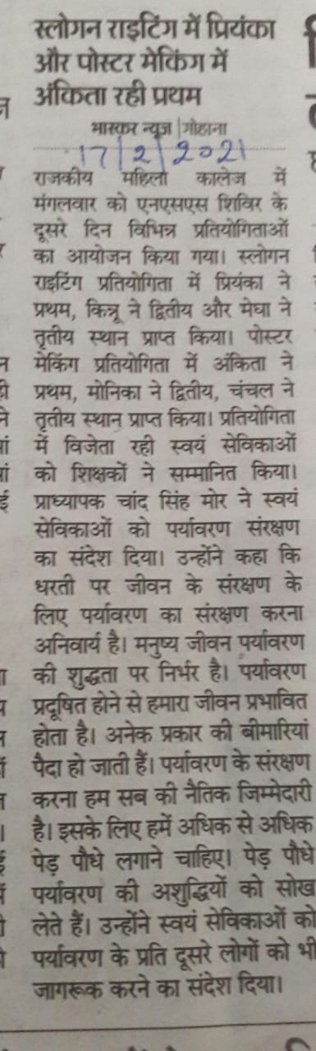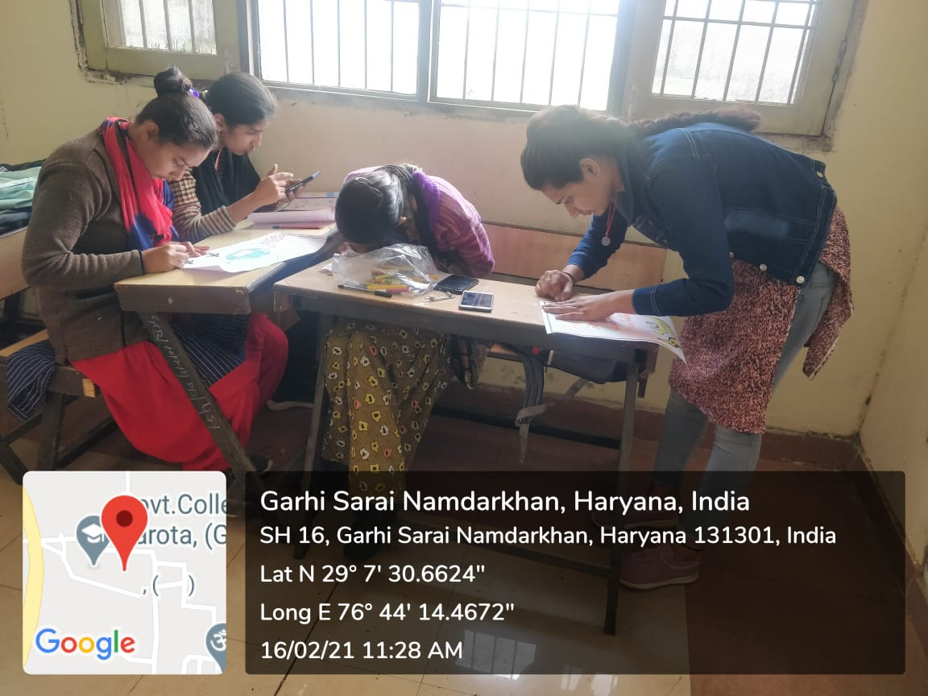

Day 3, Wednesday, Feb 17, 2021
The day was started with yoga. N.S.S.P.O. taught the volunteers about Surya Namaskar& its benefits.
Later Mr. Sanjay Kumar came to teach the students regarding First aid training and home nursing. He gave the training about what should be done if an accident happened on a road.
In the afternoon, a dance competition was organized for volunteers. A good number of volunteers participated in dance Competition.
In the evening session, Mr. Harish Bhardwaj, Senior Advocate had a participatory session with volunteers. He delivered the lecture to students about the rights of women. He stated that girls have equal rights in parental property even after marriage. He also motivated the girls not to give dowry during their marriage. Volunteers took active part in this session.
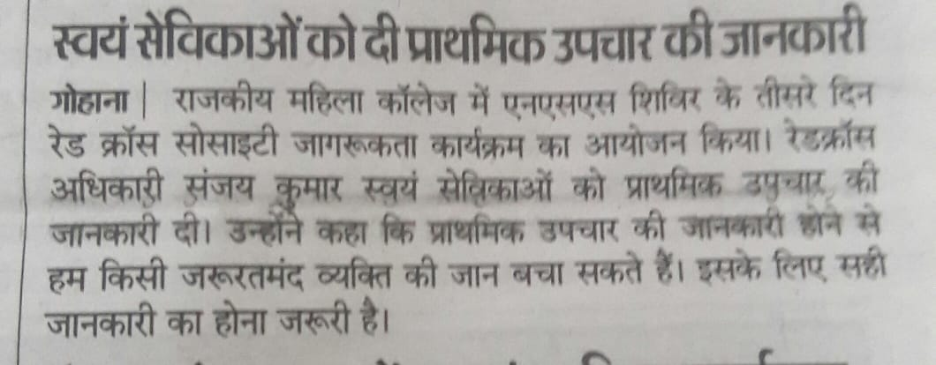
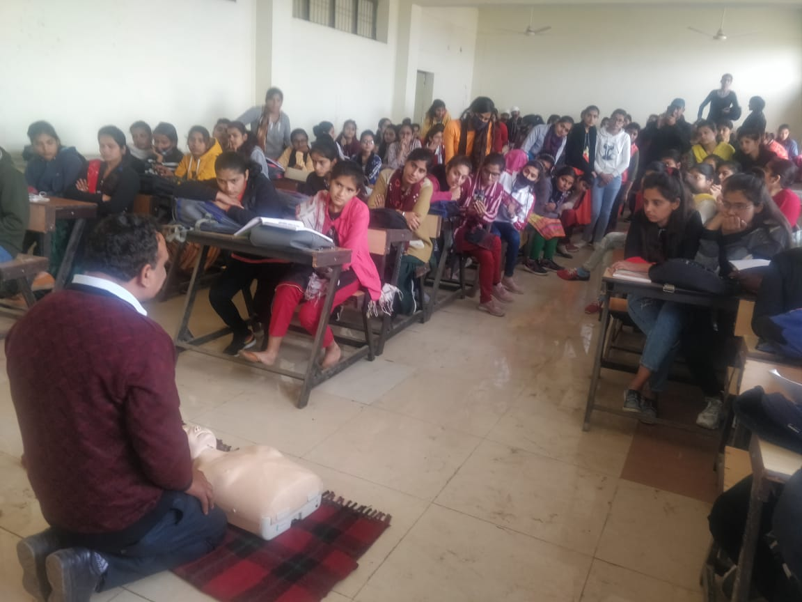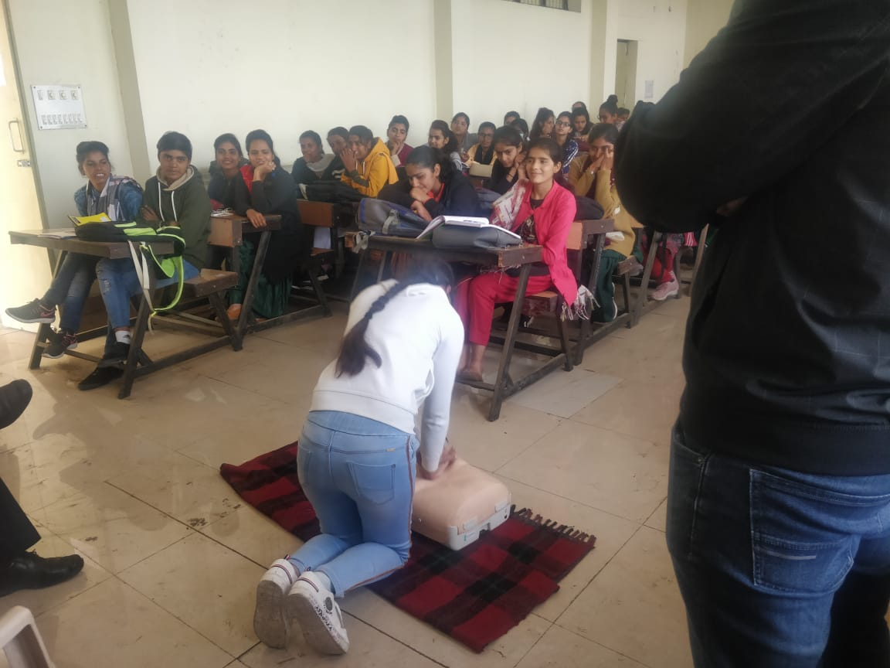

Day 4, Thursday, February 18, 2021
The day was started with yoga, prayer and chanting of Gayatri Mantra.
In first aid & Home Nursing training, Mr. Sanjay taught about the first aid to be given in case of fractured backbone. He told that the body is to be kept steady in this case while the injured is taken to doctor.
In the morning session, a rally on Beti- BachaoBeti-padho was organized the volunteers Marched through village streets . Different posters and slogans were prepared on the theme Beti- BachaoBeti-padho. In the evening session , a lecture given by Dr Dinesh on importance of Ayurveda in life. He told the students various benefits of Ayurveda like healthy and glowing skin, say goodbye to stress, lower blood pressure, cholesterol and symptoms of illness and diseases etc.
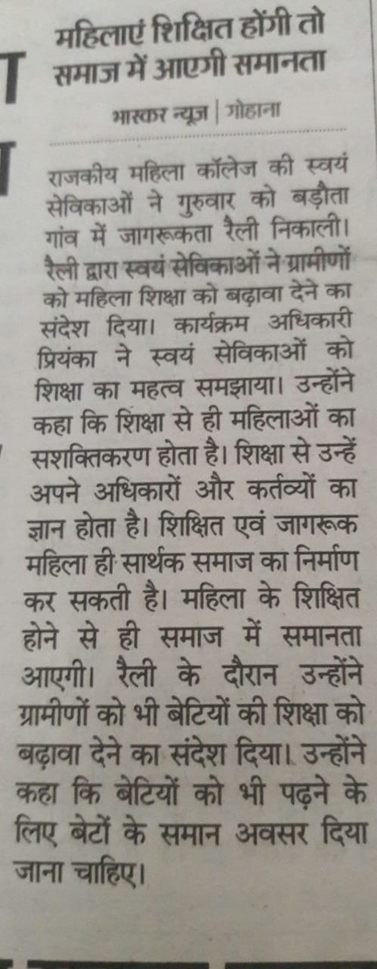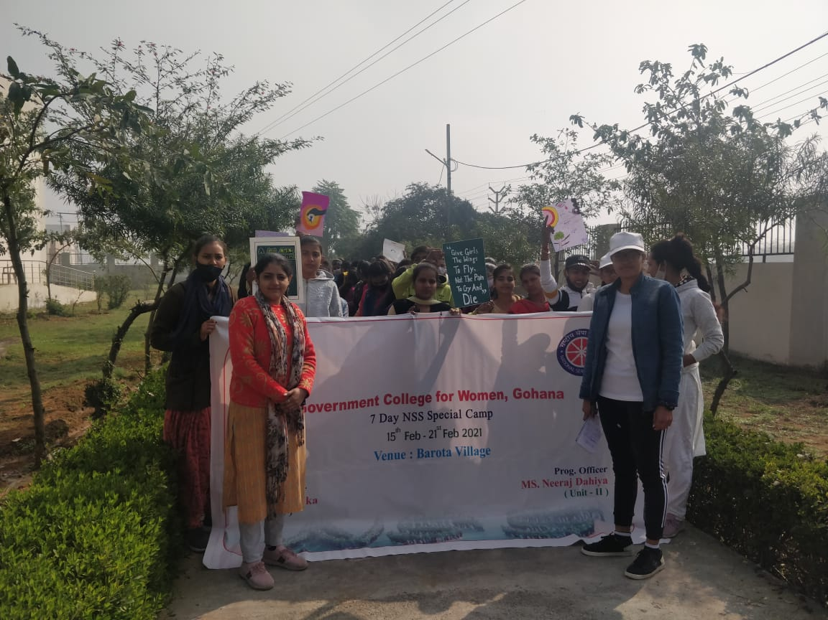

Day 5, Friday, February 19, 2021
The day was started with Yoga, prayer and chanting of Gayatri Mantra.
Mr. Sanjay Kumar, first Aid Trainer taught about how to treat a person if he/she is injured and cannot move. He taught about how injured should be taken for cure through two persons carrying in hand lock.
In the morning session, a lecture was given by Mrs. Manju Pahal on importance of yoga and hygiene. She advised the volunteers to stay away from stress and anger so that the mind remains healthy and happy. She advised volunteers regarding positivity, to remain positive in all situations of life. She advised to do “Shavasan”.
In the evening session, a lecture was given by DrSbeena on personal hygiene of women. She told that vagina is able to clean itself no special care is needed, other than washing the external genitals. Do not put anything like douches into the vagina, as the delicate skin can be damaged. She gave some personal hygiene suggestions for girls: in menstruation- wash your body, including your genital area, in the same way as you always do. Change tampons and sanitary napkins regularly, at least four to five times a day. Always wash your hands before and after handing a tampon or pad.

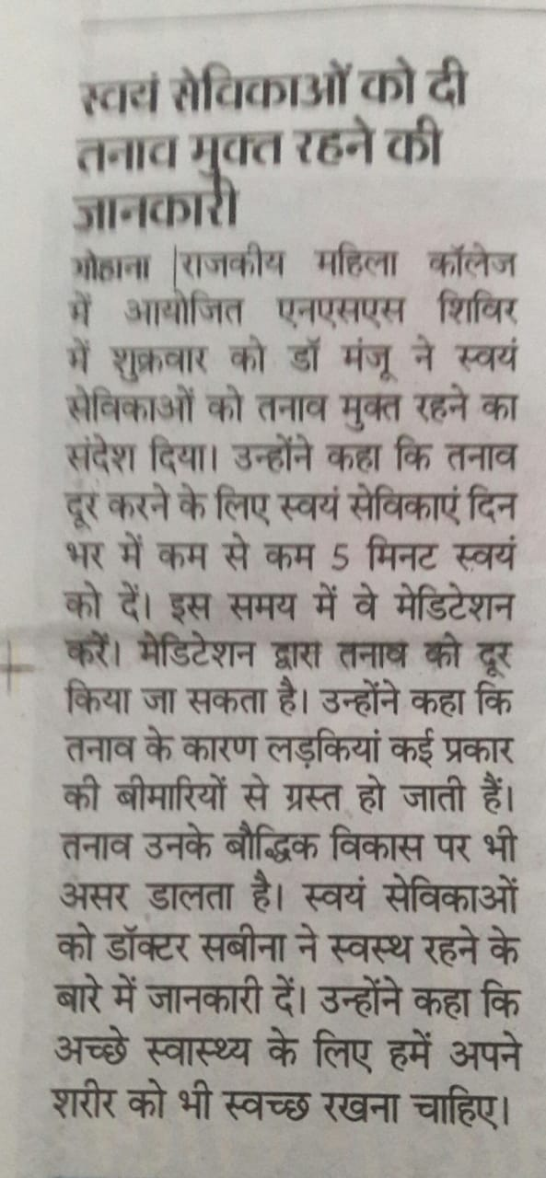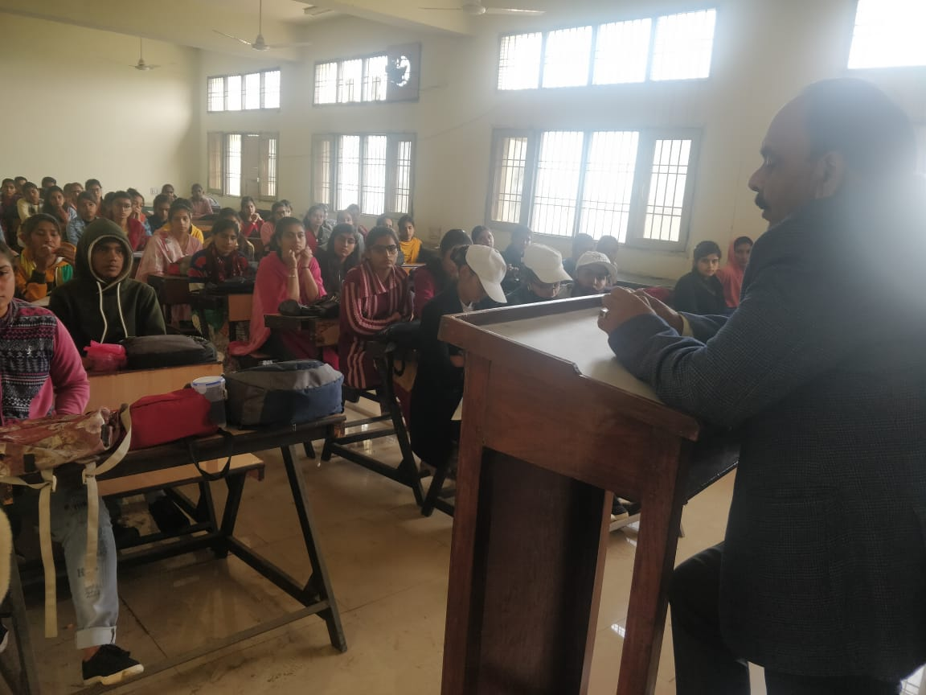

Day 6, Saturday, February 20, 2021
The day was started with Yoga, Prayer to god and Chanting of Gayatri Mantra.
Mr. Sanjay Kumar, while giving first aid and Home Nursing training taught about how to treat an injured if he knowingly or unknowingly swallows a poisonous substance. He told that in such a case, it should be made that he injured vomit so that the poisonous substance comes out of body.
After the first aid training a lecture was given by Mr. Om Parkash on the theme of improving handwriting. He taught the students. He also taught the students about the hygiene of food.In the morning session, a rally on fight against covid 19 was organized the volunteers Marched through village streets
Later a skit was performed by the volunteers in Barota village regarding the awareness of covid 19.
In the evening session, volunteers participated in cleaning the campus of government college of Barota. After that Ms. NeerajDahiya NSS PO of unit II motivated the student towards cleanliness. She also encouraged the students not to use polythene.
After that Ms. NeerajDahiya (PO of unit-II) motivated the students towards cleanliness & hygiene. He encouraged the students & not to use polythene & open defection.
The students were also encouraged to aware the peoples as well.Later volunteers participated in cleaning of campus of Government College Barota.
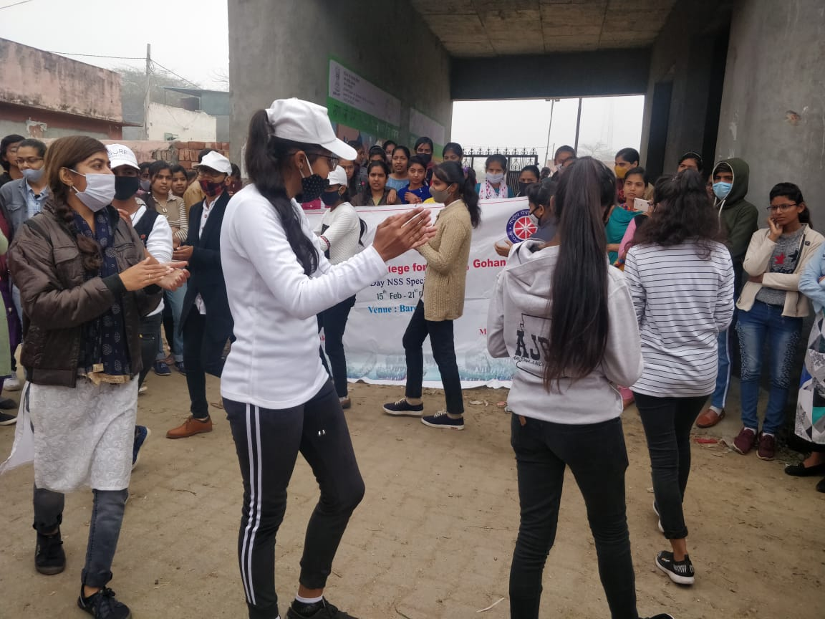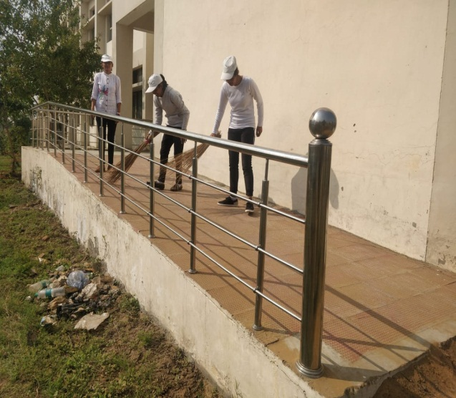

Day 7, Sunday, February 21, 2021
Day was started with yoga, prayer and chanting of Gaytri Mantra.
Mr. Sanjay Kumar concluded first aid training and home nursing training and took the test of volunteers. A total of 100 plants were planted at college campus of Barota.
In the afternoon session, valedictory session was held. It was presided by Ms. BimlaPunia. She Congratulated the volunteers and program officers of both units. All the students gave some presentations like Dancing, Acting, and Singing etc.
Certificates and moments were distributed by Ms. BimlaPunia, Ms. Priyanka (N.S.S. P.O unit- I) and Ms. NeerajDahiya (N.S.S.P.O unit II). N.S.S P.O explained all about the activities undertaken during the 7 days camp.

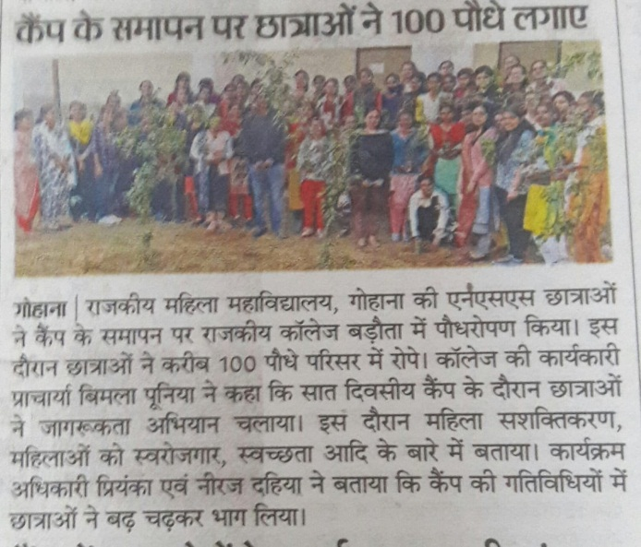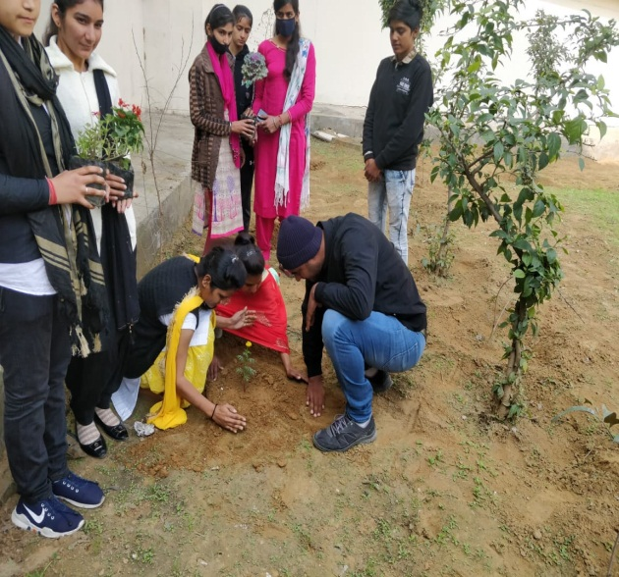

RED RIBBON CLUB

Report
On
HIV-AIDS Testing Camp

Government College for women, Gohana
30th March 2021

Submitted by:
Namita
Assistant Professor (Commerce)
Youth Red Cross (Convener)
Government College for women, Gohana

Testing Camp of HIV-AIDS
A testing camp of HIV-AIDS was conducted in the Government college for women, Gohana. The active participation was made by the students. Total 60 students in a team participated for testing camp. The doctor from Civil Hospital ,Gohana visited the college campus , she delivered a lecture to the students about the importance of being tested for HIV. She insisted the students to be aware about the disease and give some tricks to be protected from HIV.

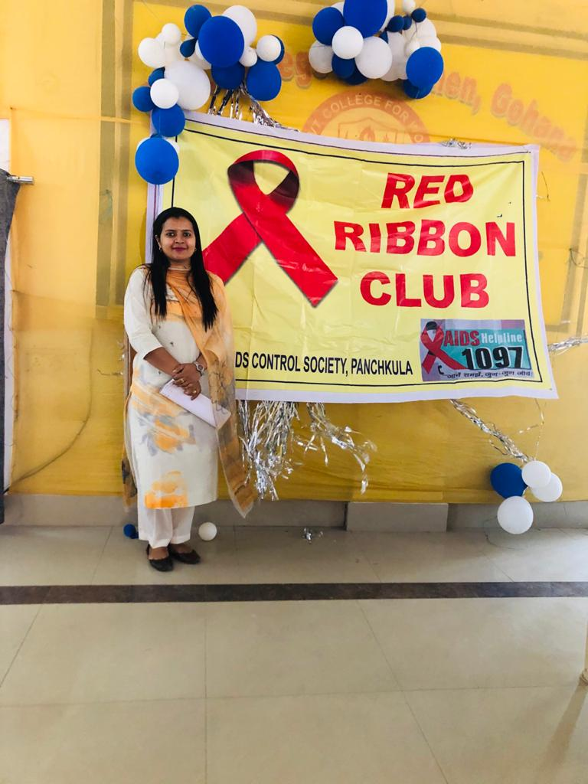
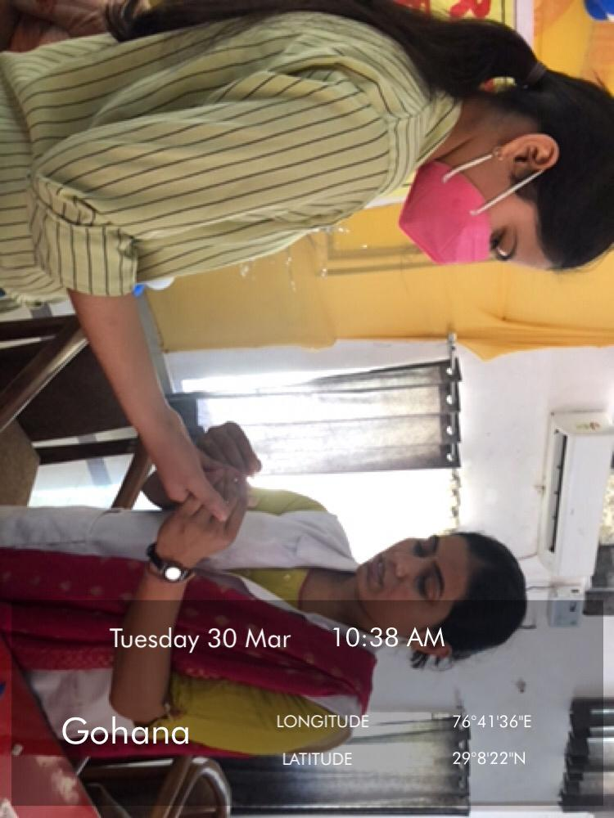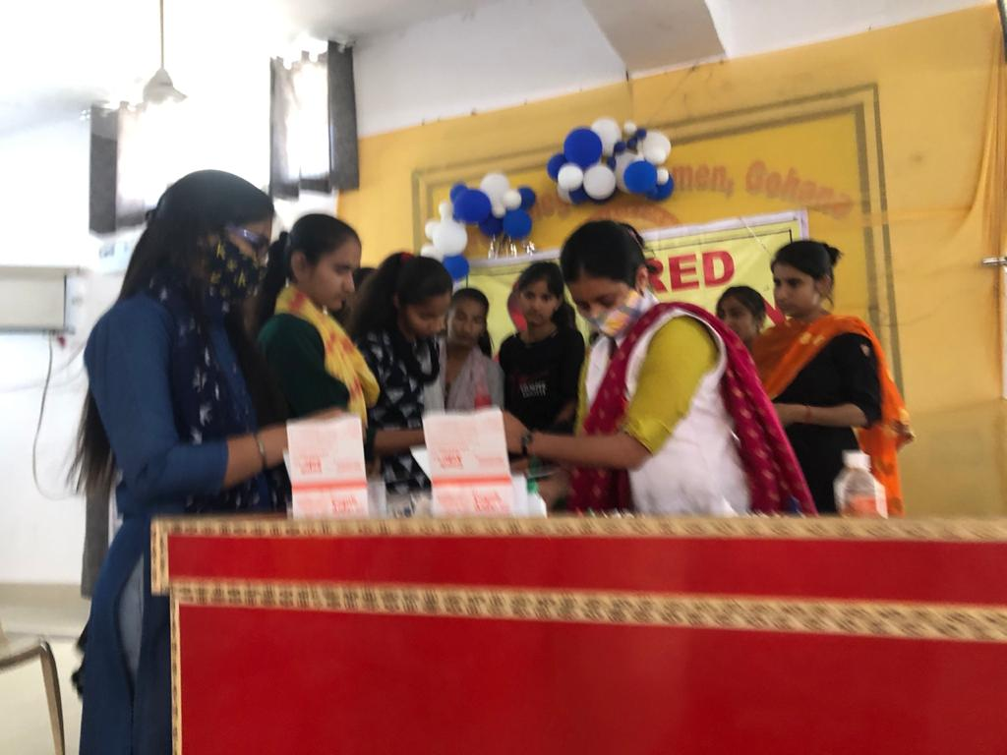

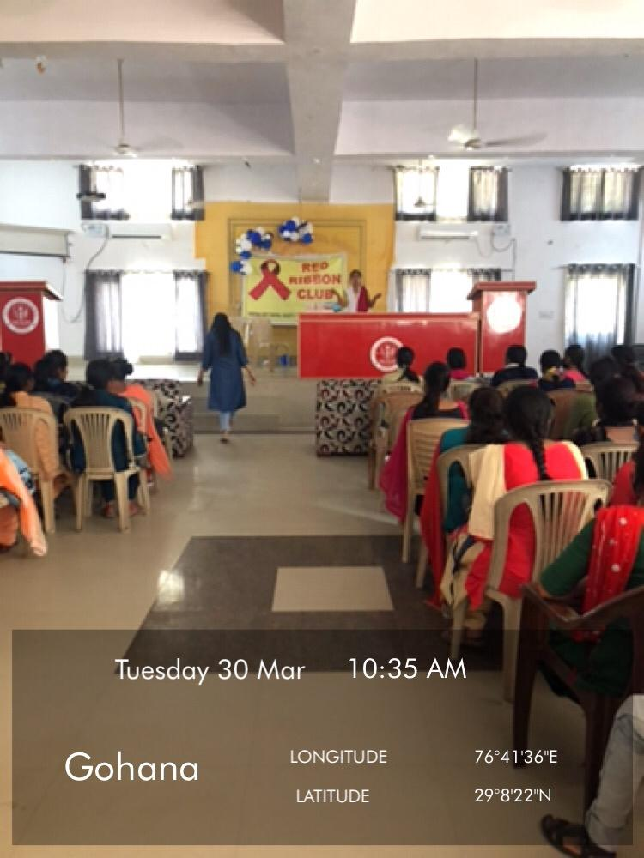

Convener Co-Convener Principal
Ms. Namita Ms. Kiran Mr. Dinesh Saharan
Ms. Ritu
Ms. Pinki
Ms. Archana

Government College for women, Gohana
YOUTH RED CROSS
&
LEGAL LITREACY CELL

Report
On
Observance of
Youth Day
On 12th-13th January 2021

Submitted by:
Mrs. Namita (Youth Red Cross Convener)
Mrs. Neha (Legal Literacy Convener)
Government College for women, Gohana

Day 1-12th January 2021
Mr. Dinesh Saharan, Principal allowed for the organization of the “Youth Day” at GCW Gohana with the aim that students gets the knowledge about youth empowerment. The students from different streams of college participated in the event. The principal told the importance of being strong and motivated youth. He lessoned the students to be ethically aware about their rules and regulations and not to practice them unfairly. He gave the examples of various historic personalities motivated them to follow the right path
With the inaugural session was started by the speech of by Mr. Dinesh Saharan and then slogan writing competition was conducted at the multipurpose hall of the college. The theme for the slogan writing competition was “Role of youth in nation building” best slogans were selected by the panel of judges. Prachi, B.Sc. (Non-Med.) stood first ,Khushboo B.Sc. (Med) stood second and Priyanka BA (Com. Sc.) stood third in the competition.

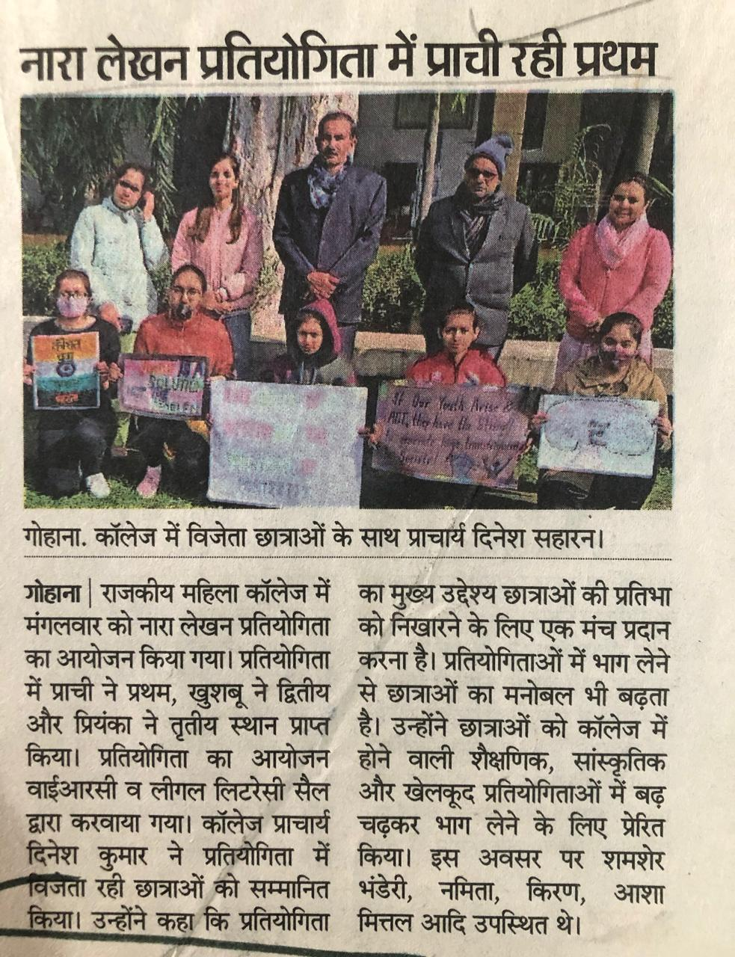

Day 2- 13th January 2021
On the day second of the event "Youth Day" a lecture was organized on the topic "Role of youth in nation building". Mrs. Namita and Mrs. Neha welcomed the chief guest and principle with great enthusiasm. In this session Mr. RamphalMor, Chairman of AdhyoshParishad ,Sonipat was invited to deliver the lecture. He motivated the students for becoming a good citizens of the country. He shared various experiences from his life and history by giving various examples. He intracted with the students and performed his duties very well. Later on Principal Mr. Dinesh Saharan thanked the speaker and motivated the students to infuse enthusiasm in their life's. Student paid attention to the speech with great zeal and enjoyed the lecture.

